Table of Contents

**Class Schedule** 4

**Workshop Preparations** 6

**Reel Holder Sub-Assembly** 8

**LCD Screen Sub-Assembly** 10

**X, Y, and Z Limit Switches** 15

Solid State Relay Sub-Assembly 20

Electronics Tray Sub-Assembly 22

Electronics Tray Pre-Wiring Guide 28

X-Stage Supports Sub-Assembly 30

Z Rod Supports Sub-Assembly 36

Low-Mass Extruder Assembly 39

**Bottom Frame Assembly** 58

**Upright Frame Assembly** 64

**Y Stage Assembly** 72

**Z Stage Assembly** 84

**X Stage Assembly** 91

Heated Bed Assembly 110

Mechanical Systems Test 114

**Motor Jog Test:** 114

**Calibrating the positions of Y and Z Limit Switches:** 114

**Check the Heating and Cooling Components:** 115

**Setting up the flexMendel in the Classroom** 117

Bedplate Leveling 118

The Critical 1st Layer 122

flexMendel Operation – 125

RepRap Smart LCD Controller 125

RepRap Smart LCD Controller Menu Map: 126

To Print a File from the SD card: 127

3D Printer calibration settings that can be changed on-the-fly: 128

Basic 3D Printer Operational Procedures 129

flexMendel Maintenance 131

Preventative Maintenance 131

**Solutions to Minimize Damage from Dust** 132

**Ongoing flexMendel Maintenance** 133

Pre-Printing Check List 137

Slic3r Introduction 138

Introduction and Background 138

Getting Started: Download and Install Slic3r 139

Getting Started: Turn on "Expert Mode" 142

Getting Started: Loading a "Config File" 142

Slic3r Setting Descriptions: b.) Print Settings Tab – Layers and Perimeters 146

Slic3r Setting Descriptions: b.) Print Settings Tab – Infill 148

Slic3r Setting Descriptions: b.) Print Settings Tab – Speed 150

Slic3r Setting Descriptions: b.) Print Settings Tab – Skirt and Brim 151

Slic3r Setting Descriptions: b.) Printer Settings Tab – Support Material 152

Slic3r Setting Descriptions: b.) Print Settings Tab – Note 153

Slic3r Setting Descriptions: b.) Print Settings Tab – Output options 154

Slic3r Setting Descriptions: b.) Print Settings Tab – Multiple Extruders 154

Slic3r Setting Descriptions: b.) Print Settings Tab – Advanced 155

Slic3r Setting Descriptions: c.) Filament Settings Tab – Filament 156

Slic3r Setting Descriptions: c.) Filament Settings Tab – Cooling 157

Slic3r Setting Descriptions: d.) Printer Settings Tab – General 158

Slic3r Setting Descriptions: d.) Printer Settings Tab – Custom G-code 159

Slic3r Setting Descriptions: d.) Printer Settings Tab – Extruder 1 160

Creating Your Own Config Files in Slic3r 162

Ongoing Cost Estimations 169

Troubleshooting 171

Safety Hazards of the flexMendel 173

flexMendel Part Identification Key 176

# **Class Schedule**

Week 1:

• Introduction

• Sub-assemblies of printer parts

Week 2:

• Open source 3D printer firmware introduction

• Flash Firmware

• Assemble Hotend

Week 3:

• Build Low-Mass Extruder

• Mechanical Assembly

• Aluminum frame

Week 4:

• Y carnage, motor, idler

• Z stage, rods, motors, guides

• X axis, motor, idler, Extruder

• Electrical Assembly

Week 5:

• RAMPs wiring

• Motors and limit switches

• AC power cord

Week 6:

• LCD Smart Controller

• Heated bed/SS Relay

Week 7:

• Turn on printer/ motor jog test

• Calibration and binding tests

• Calibrate Z Axis

• Bed Leveling

Week 8:

• First Print! - Razor Scraper

• 3D Printer Calibration

• Bed leveling techniques

• Calibrating the extruder with test prints

Week 9:

• Slic3r - G-Code Generator

• Creating a default config file

• Basic/Advanced print settings

• Exporting G Code files

Week 10:

• Limitations of a 3D Printer

• Design Intent

• Part Feature Optimization

Week 11:

• Open Source 3D Printer Resources

• Thingiverse

• NetFABB

• 123DApps

• RepRap community

• Question and Answer Session

# **Class Preparations**

* Purchase all components from the BOM list
* Prepare CNC Milled Part Kits
  + UHMW Slides
    - Cut blanks from bar stock
    - Mill ySlideleft, ySlideRight, and zSlides
  + Filament Shaft
    - Cut blanks from bar stock
    - File setscrew notch
    - Mill filament teeth
* Prepare 3D Printed Part Kits
  + 3D print all parts
  + Count, sort, check
* Prepare Hardware Kits
  + Count and sort needed hardware
  + Organize into bins/bags
* Prepare Electrical Kits
  + Cut stepper motor wire lengths:
    - X-75cm
    - Y-45cm
    - LZ-26cm
    - RZ-52cm
    - Extruder motor -13cm
  + Ribbon cable prep:
    - Cut to 117cm
    - Extruder end - attach 10-pin female connector
    - RAMPs end
      * Black and white - 2-Pin female connector (thermistor)
      * Purple and grey - strip and tin - (hotend heating element)
      * Orange, yellow, green, blue - 4- Pin female connector (extruder motor)
      * Brown and red - strip and tin (extruder fan)
  + Bed GND wire - 55cm
    - Ring terminal to one end
    - Fork terminal to the other end
  + Bed Thermistor wire - 44cm
    - Solder to 100k thermistor
    - Encase in Kapton tape
    - Assemble under heating pad
  + AC SS Relay wire - 29cm
    - Fork terminals both wires on one end
    - Strip and tin both wires on the other, attach butt splice to neutral wire
  + DC SS Relay wire - 27cm
* Strip and tin all ends
* 12V DC to RAMPs - 27cm+5cm jumpers
  + - Fork terminals both wires on one end
    - Attach 5cm jumpers to other end
* AC Power Switch wire - 69cm
  + - Switch side - hot wire shielded terminal to outer pin on "O" side, load wire shielded terminal to center pin
    - Power supply side - Strip 15mm from hot wire, fork terminal on load wire
* AC Wall Plug wire - 5' extension cord
* GFCI plug attached to wall side
* Power supply side - Black (hot) strip 15mm, Fork terminals on neutral and GND (white and green)
* Limit Switch wires
* X - 74cm, Y - 30cm, Z - 30cm
* 30mm Box Fans
* Strip and tin wires
* Big wire sheath - cut 55cm and 18cm
* Small wire sheath - cut 30cm
* Add yellow wing nut and electrical tape
* Add 2 large and 15 small zip ties for wire management
* Assemble SS Relay Bracket
* Assemble LCD Smart Controllers
* Prepare 3D Printer Toolbox Kits
* Remove tools from packaging
* Sort and put into toolboxes
* Prepare "Build Your Own 3D Printer" Manual Kits
  + - Print all pages
* Put into binders
  + - Load all files onto USB drives
* Add Flashlight Pens
* Add 1kg Reel of PLA Filament

# **Reel Holder Sub-Assembly**

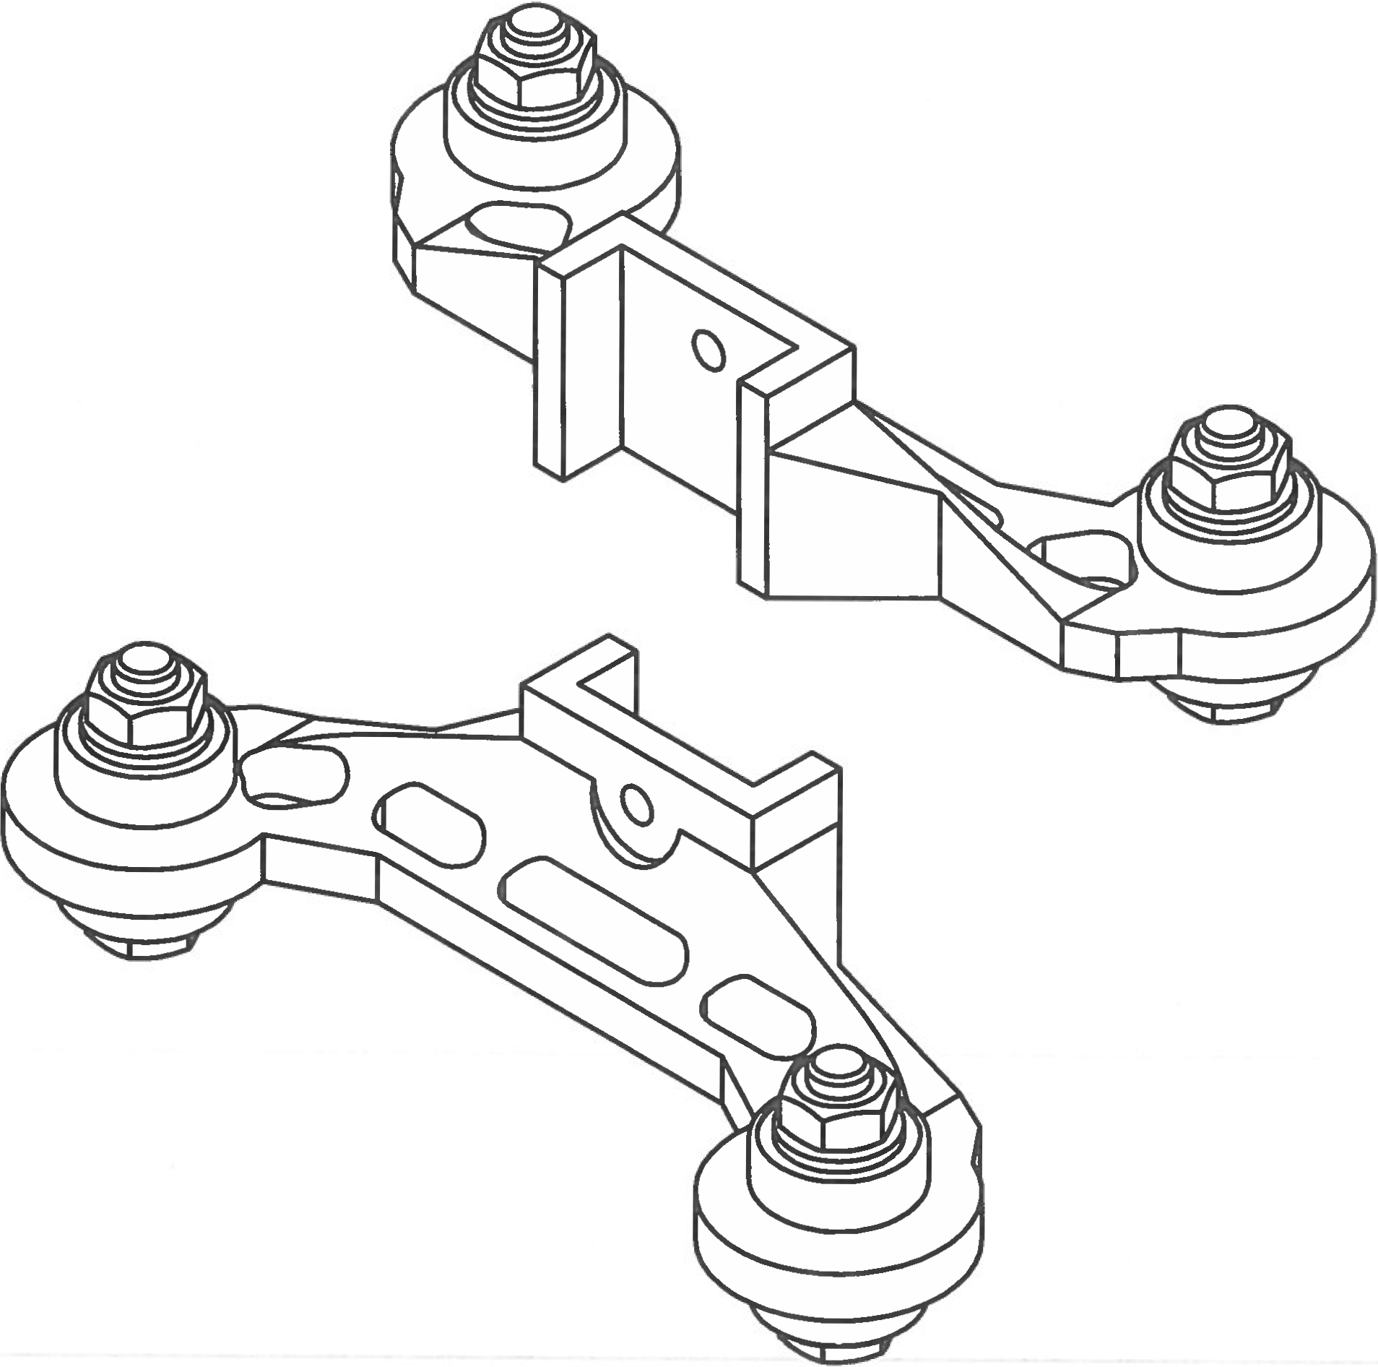

Step 1

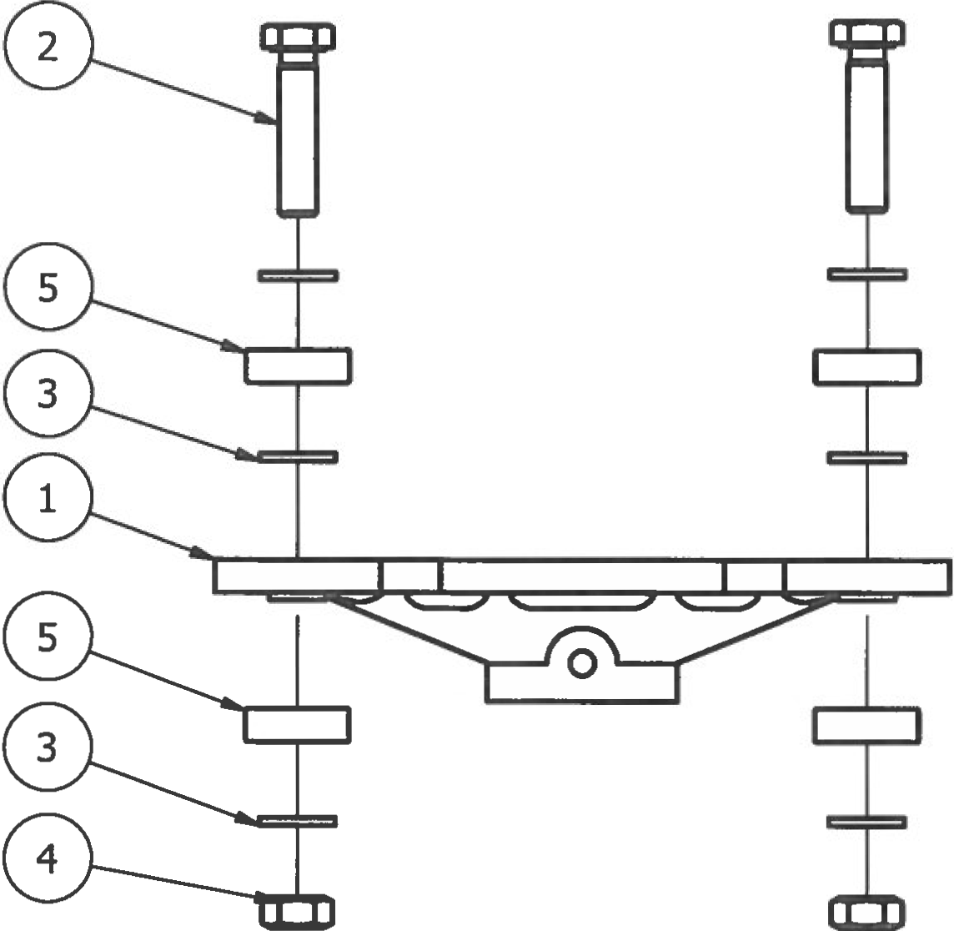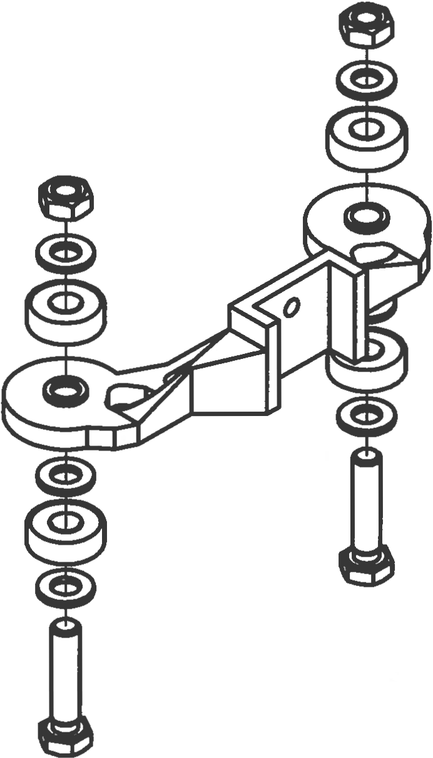

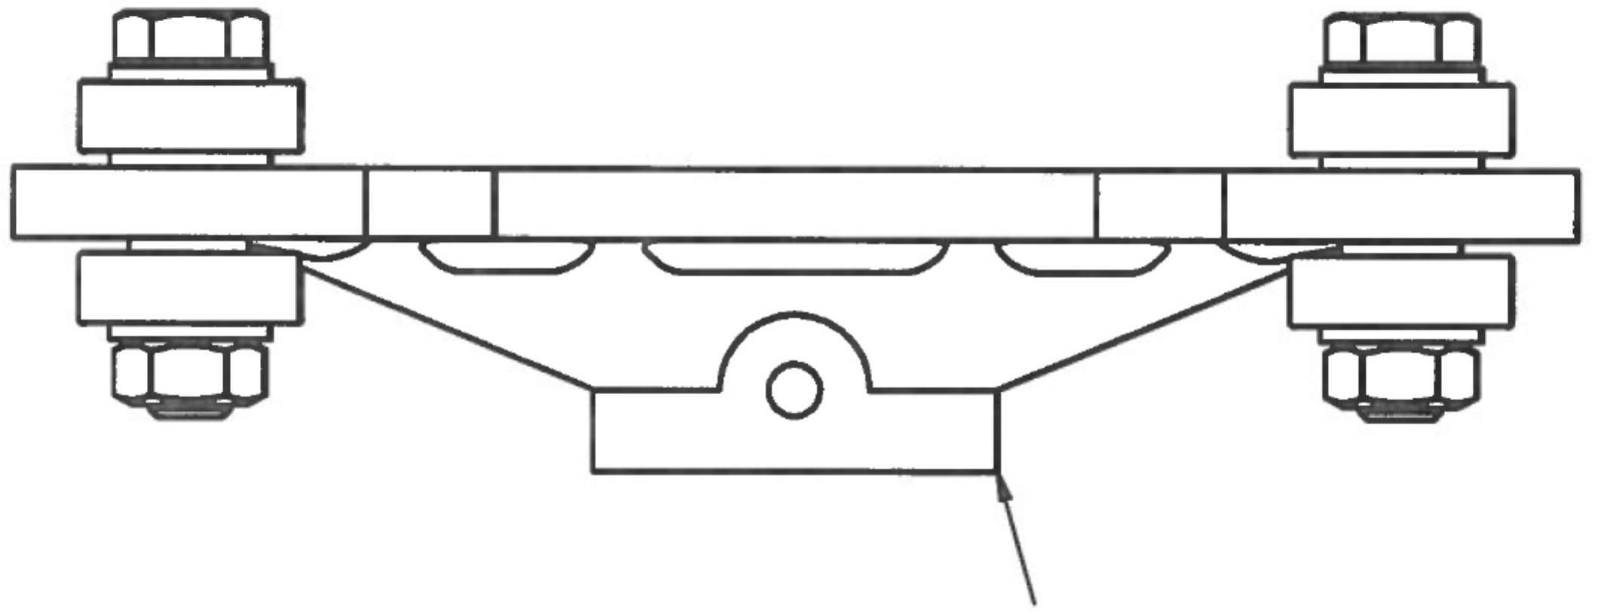

1. Assemble reel holder as shown in diagram. Reel holder sub-assembly complete

|  |  |  |  |
| --- | --- | --- | --- |
| **PARTS LIST** | | | |
| **ITEM** | **QTY** | **PART NUMBER** | **DESCRIPTION** |
| 1 | 2 | reelHolderV3 | 3D printed part |
| 2 | 4 | M8 x 35 Hex Bolt | Nuts and bolts |
| 3 | 12 | M8 Washer | Nuts and bolts |
| 4 | 4 | M8 Nut | Nuts and bolts |
| 5 | 4 | 608zz Bearing | Off-the-shelf components |
|  | 2 | 13mm Wrench | Tools |

1. Repeat process for identical reel holder.

# **LCD Screen Sub-Assembly**

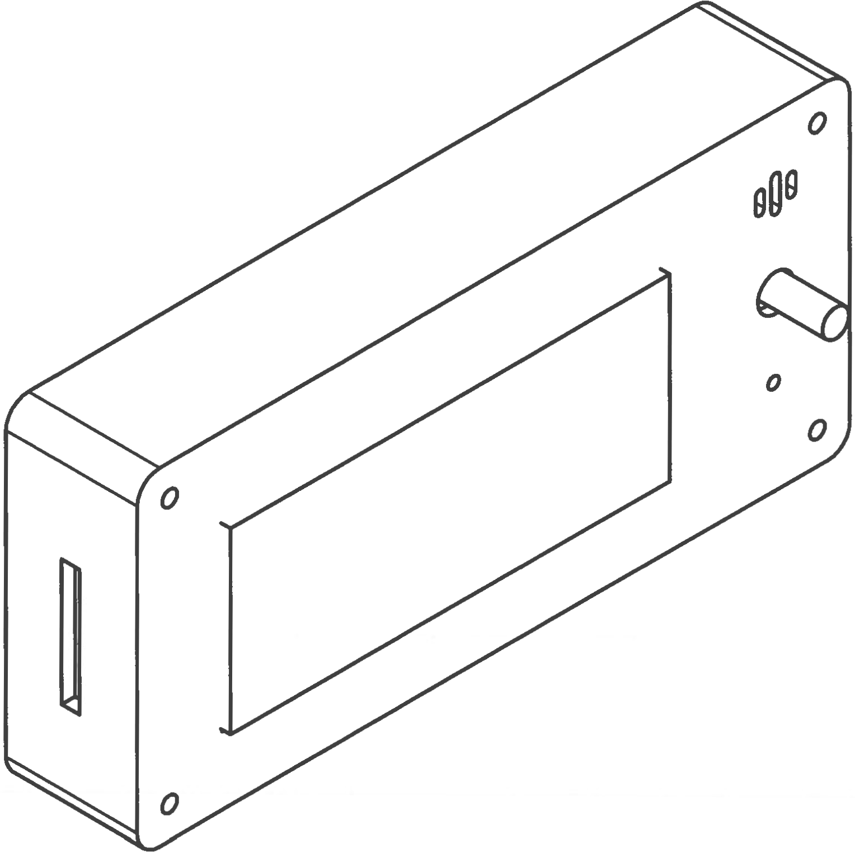

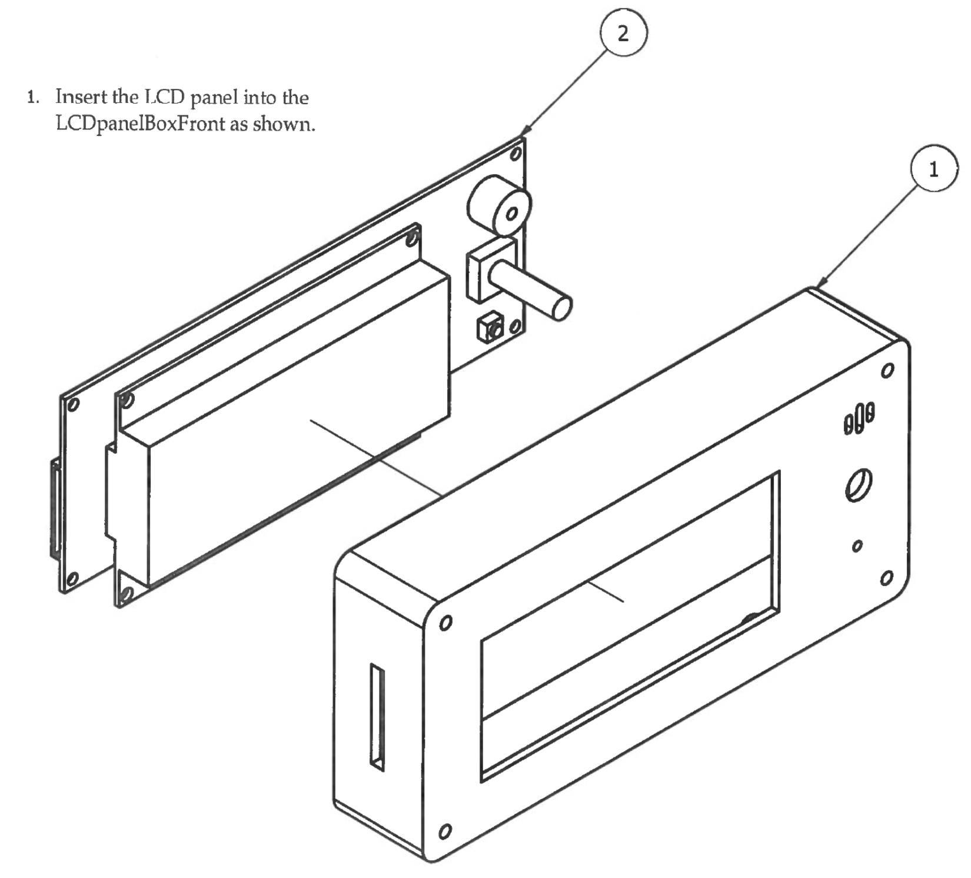Step 1

|  |  |  |  |
| --- | --- | --- | --- |
| **PARTS LIST** | | | |
| **ITEM** | **QTY** | **PART NUMBER** | **DESCRIPTION** |
| 1 | 1 | LCDpanelBoxFront | 3D printed part |
| 2 | 1 | LCDsmartController | Off-the-shelf component |

Step 2

1. 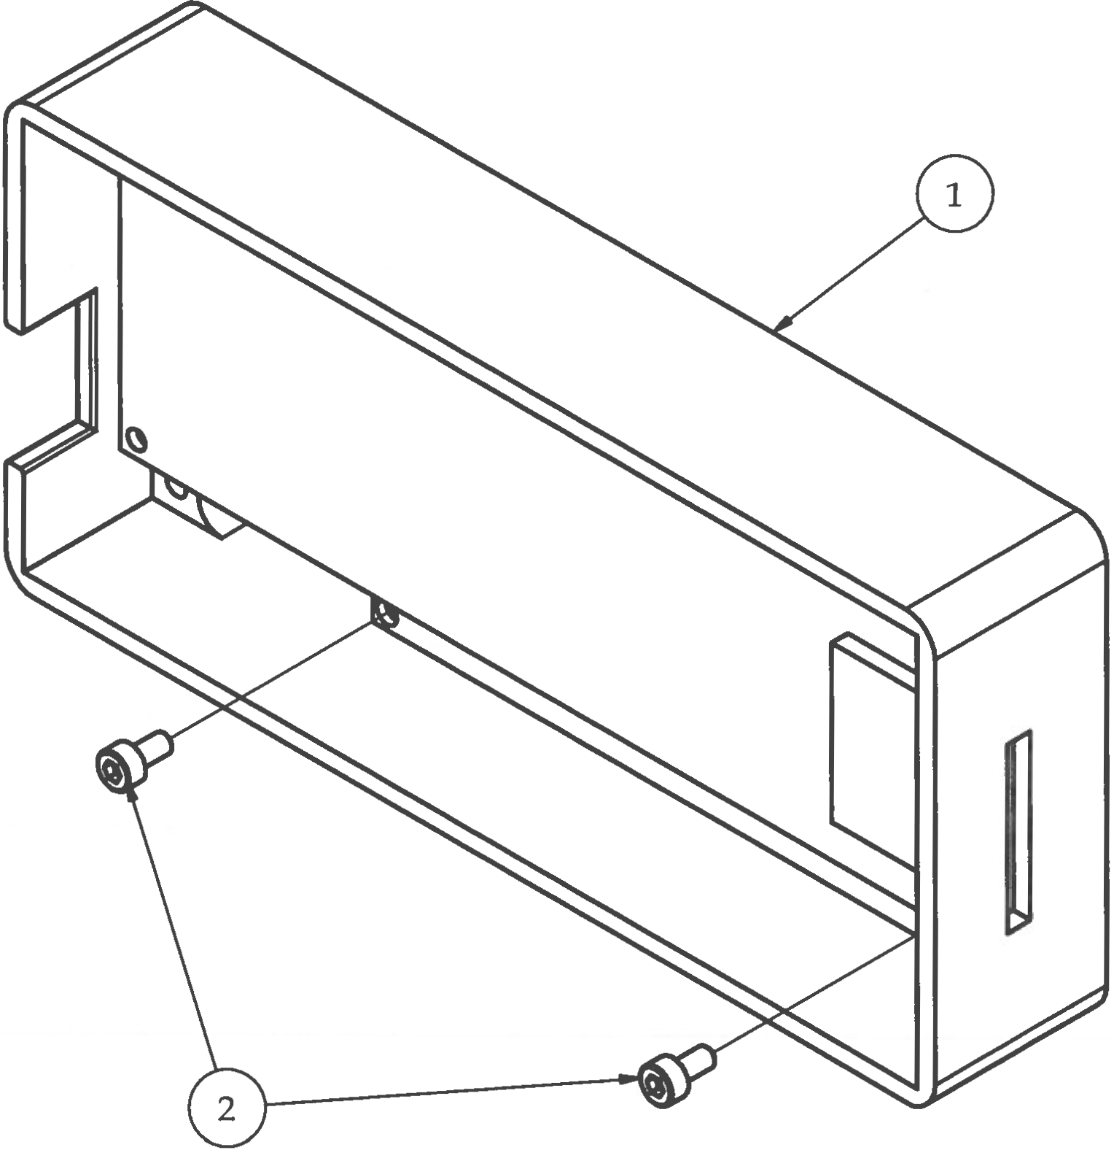Secure LCD panel to the LCDpanelBoxFront using (2) M3x6 socket head screws. Do not over tighten bolts will self-tap into the 3D printed part.

|  |  |  |  |
| --- | --- | --- | --- |
| **PARTS LIST** | | | |
| **ITEM** | **QTY** | **PART NUMBER** | **DESCRIPTION** |
| 1 | 1 | Step 1 | Previous sub-assembly |
| 2 | 2 | M3 x 6 | Nuts and bolts |
|  | 1 | M2.5 Hex Wrench | Tools |

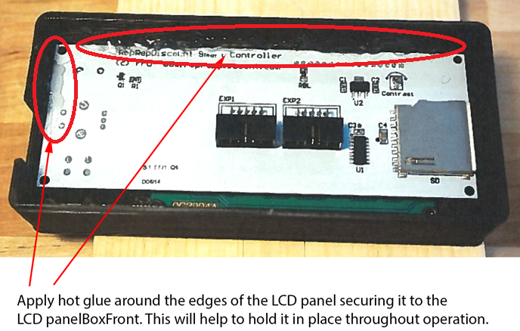Step 3

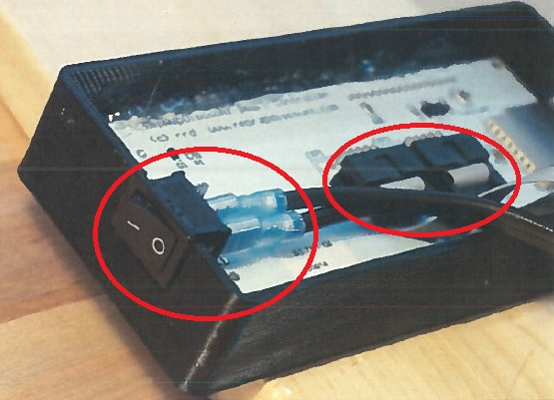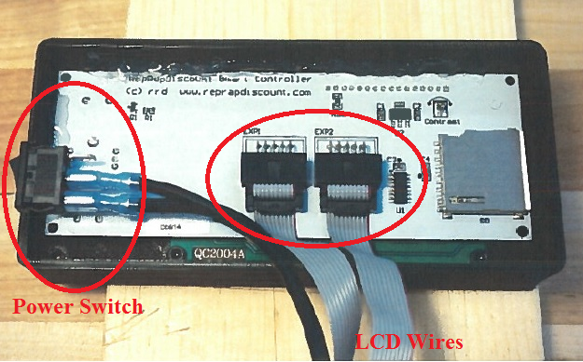Step 4

Attach LCD wires and AC Power Switch in correct orientation

# **X, Y, and Z Limit Switches**

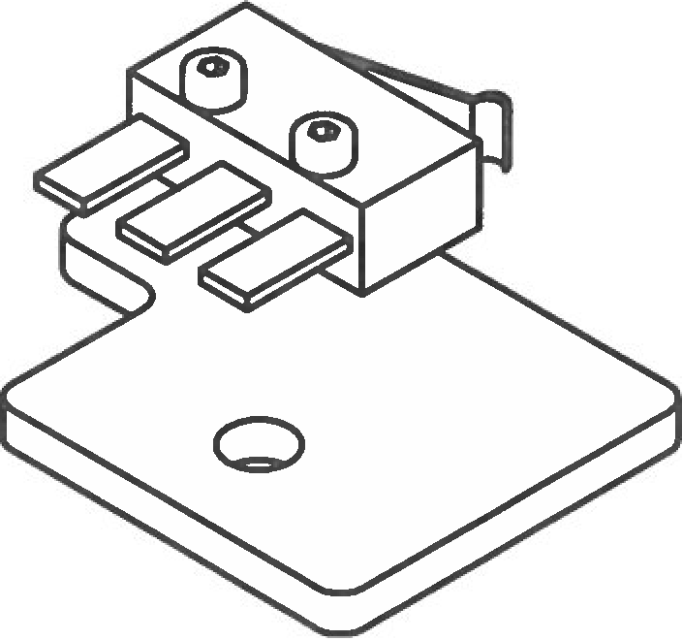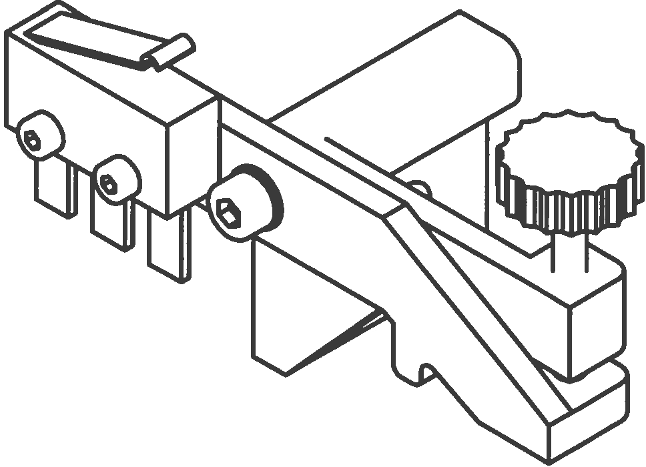

Step 1

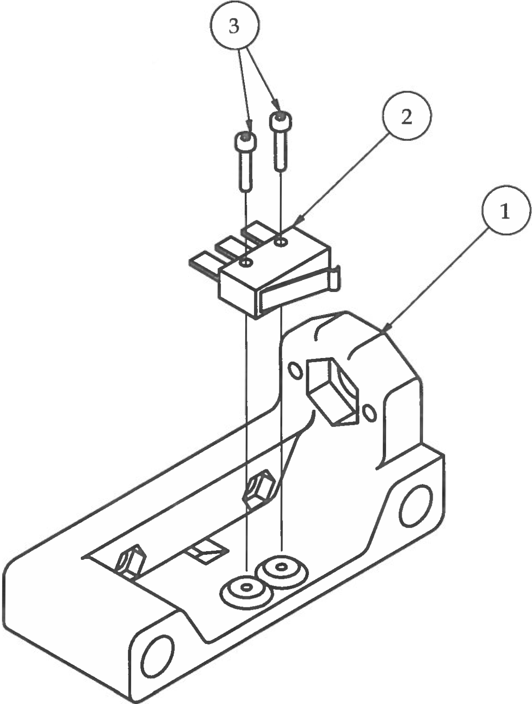

|  |  |  |  |
| --- | --- | --- | --- |
| **PARTS LIST** | | | |
| **ITEM** | **QTY** | **PART NUMBER** | **DESCRIPTION** |
| 1 | 1 | xRodSupportMotorV2 | 3D printed part |
| 2 | 1 | limitSwitch | Electrical component |
| 3 | 2 | M2 x 10 | Nuts and bolts |
|  |  | M1.5 Wrench | Tools |

1. Feed limit switch wire through the small opening in center of part.

2. Attach X Limit switch to xRodSupportMotorV2 as shown.

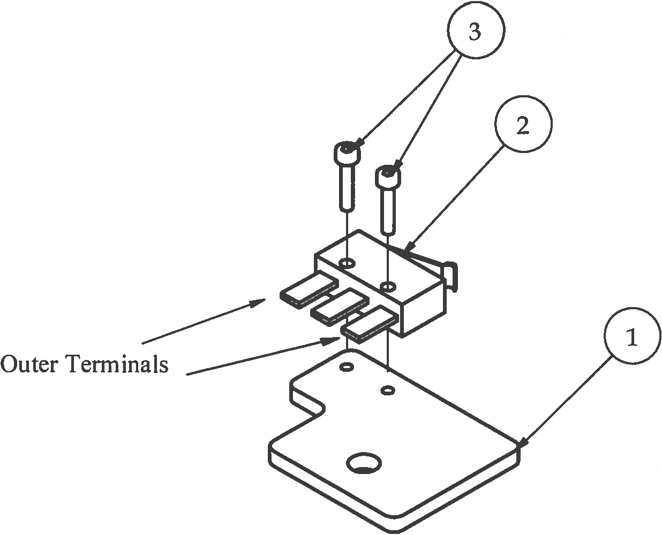Step 2

1. Locate black limit switch wires with shielded connectors on one end and

a double female pin connector on the other for wiring.

1. Attach shielded connectors to the two outer terminals on the limit switch.
2. Attach Y limit switch to yLimitBkt in orientation shown in picture.

|  |  |  |  |
| --- | --- | --- | --- |
| **PARTS LIST** | | | |
| **ITEM** | **QTY** | **PART NUMBER** | **DESCRIPTION** |
| 1 | 1 | yLimitBkt | 3D printed part |
| 2 | 1 | limitSwitch | Electrical component |
| 3 | 2 | M2 x 10 | Nuts and bolts |
|  |  | M1.5 Hex Wrench | Tools |

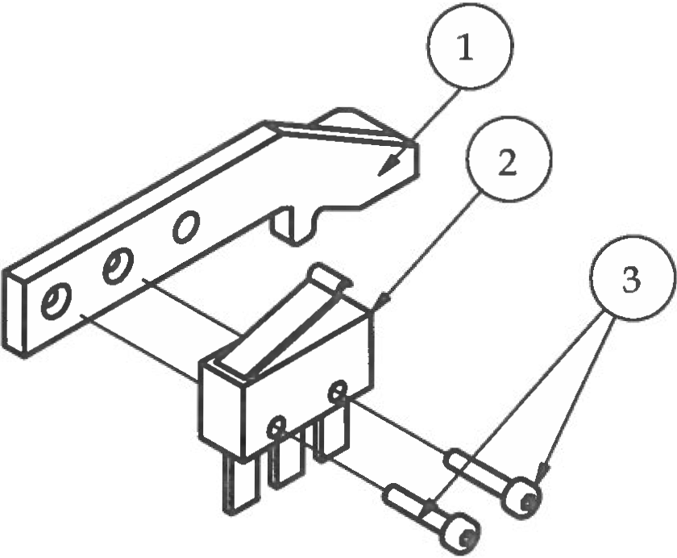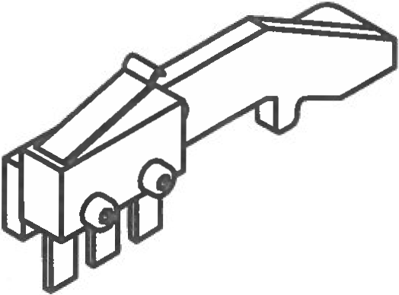Step 3

1. Locate black limit switch wires with shielded connectors on one end and a double female pin connector on the other for wiring.

2. Attach shielded connectors to the two outer terminals on the limit switch. Attach Z limit switch to adjZLimitSwitchLever as shown.

3. Tap the hole for the adjustment screw using a M3 x 20 socket head bolt as shown in the lower-left picture. Do this by slowly driving the bolt all the way into the hole and back out 2-3 times until it you are able to screw it in and out by hand. If necessary you can add a drop of 3-in-1 Oil to lubricate as you tap. DO NOT OVER TIGHTEN or you will strip the threads and the mechanism will not function properly.

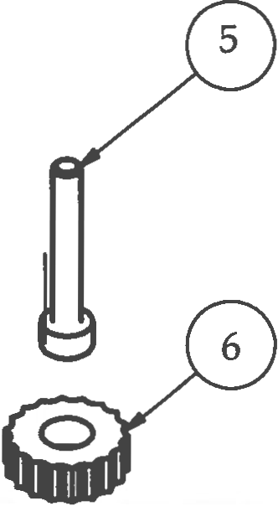4. Remove the M3 x 20 bolt and glue the tiny 3D printed knob to the head of the bolt as shown in the lower-right picture. Wait for glue to dry.

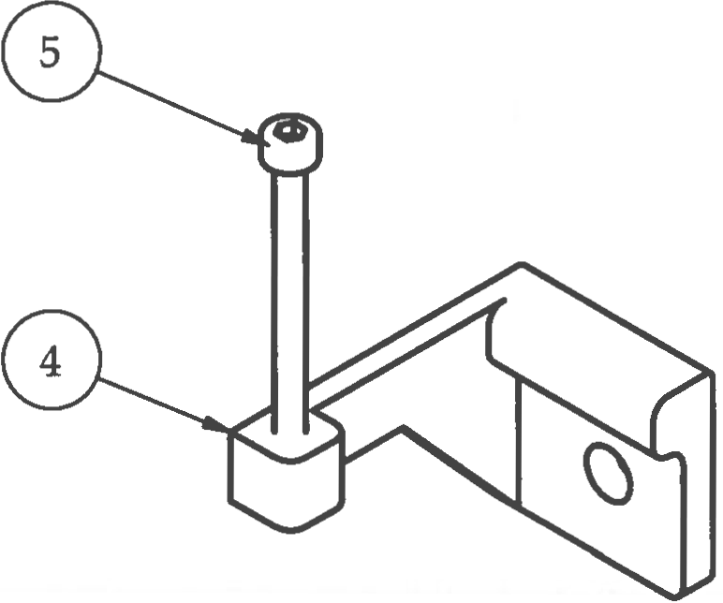

|  |  |  |  |
| --- | --- | --- | --- |
| **PARTS LIST** | | | |
| **ITEM** | **QTY** | **PART NUMBER** | **DESCRIPTION** |
| 1 | 1 | adjLimitSwitchLever | 3D printed part |
| 2 | 1 | limitSwitch | Electrical component |
| 3 | 2 | M2 x 10 | Nuts and bolts |
| 4 | 1 | adjLimitSwitchBracket | 3D printed part |
| 5 | 1 | M3 x 20 | Nuts and bolts |
| 6 | 1 | knobTiny | 3D printed part |
|  |  | M1.5 Hex Wrench | Tools |
|  |  | M2.5 Hex Wrench | Tools |

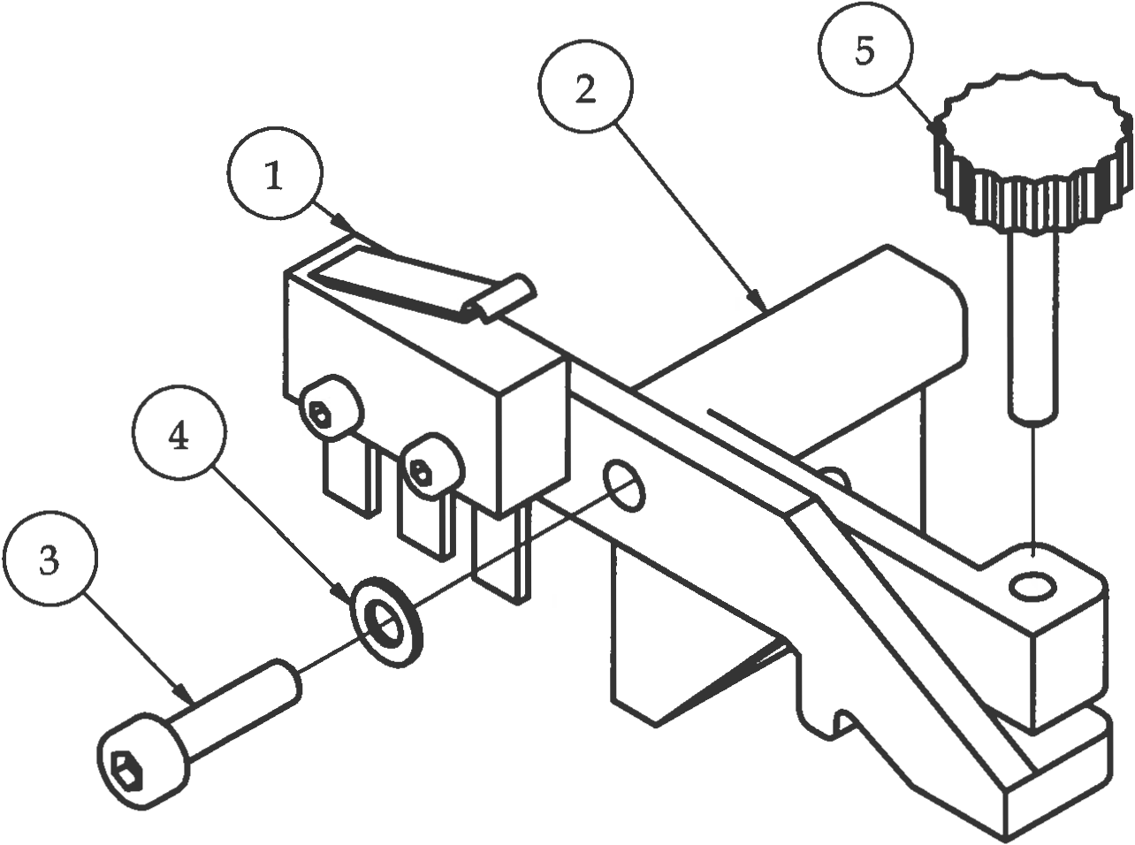Step 4

1. Attach adjZLimitLever to adjZLimitBrk using M3 x 12 bolt and M3 washer. DO NOT tighten down completely! Leave about a 1mm gap to all for the lever to move freely up and down.

2. Hand tighten the M3 x 20 bolt with the 3D printed knob into the hole as shown. Make sure you can do this by hand. If you are unable to screw in this bolt by hand, re-tap the thread and try again.

3. Place small rubber band around the lever and bracket as shown in the photo to secure the bottom of lever to the bottom of the M3 x 20 bolt.

4. The adjustable Z limit switch is now complete.

|  |  |  |  |
| --- | --- | --- | --- |
| **PARTS LIST** | | | |
| **ITEM** | **QTY** | **PART NUMBER** | **DESCRIPTION** |
| 1 | 1 | Step 3 | Previous sub-assembly |
| 2 | 1 | adjZLimitBrk | 3D printed part |
| 3 | 1 | M3 x 12 | Nuts and bolts |
| 4 | 1 | M3 Washer | Nuts and bolts |
| 5 | 1 | Step 5 | Previous sub-assembly |
|  |  | M2.5 Hex Wrench | Tools |

# Solid State Relay Sub-Assembly

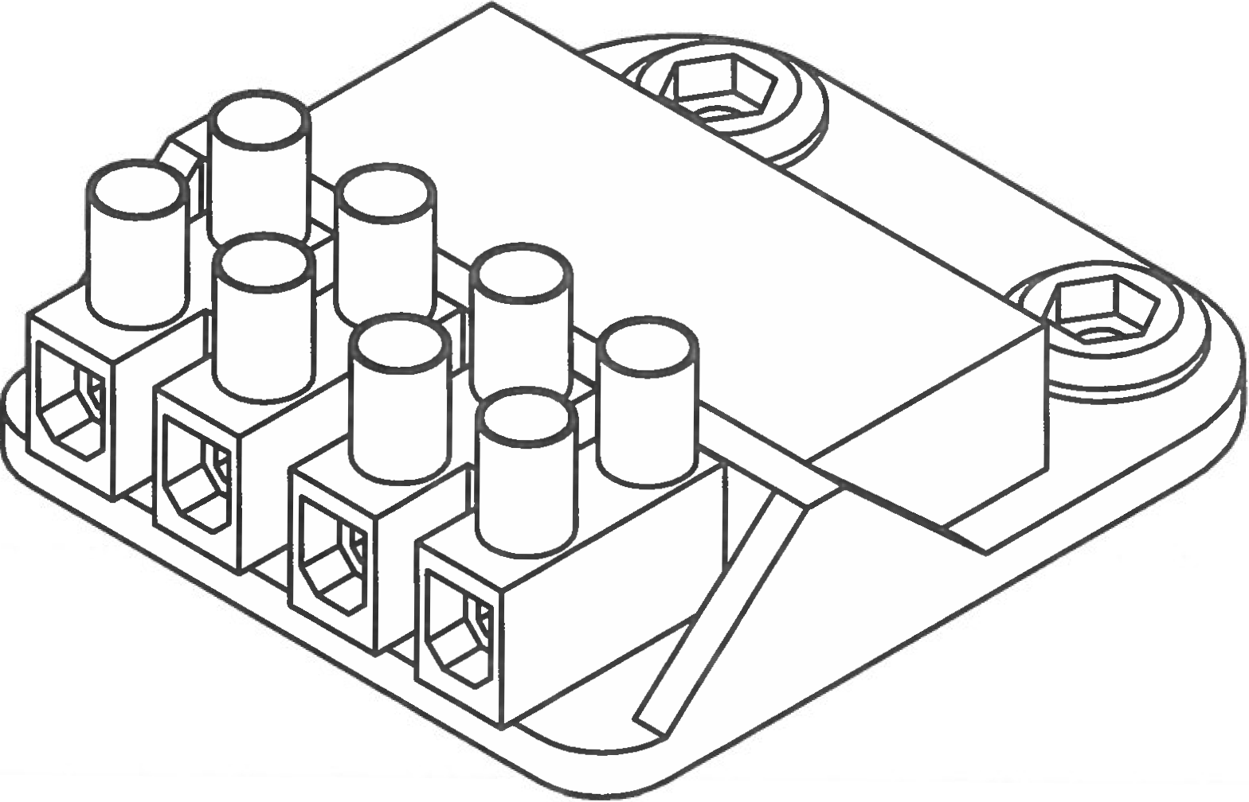

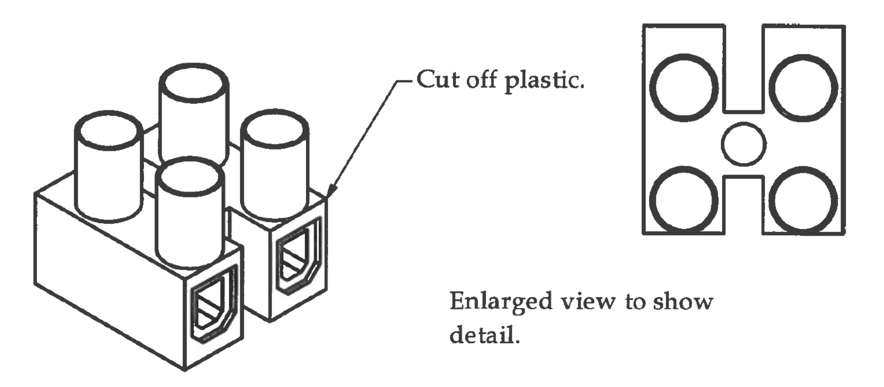Step 1

1. Using a razor knife, cut the Euro terminal strips into 2-terminal sections.

2. Cut the plastic protectors off of one side as shown in the pictures in the upper pictures on the page.

3. Insert solid state relay into the 3D printed solid state relay bracket. The holes should line up perfectly with the wire leads coming out of the solid state relay.

4. Place a dab of hot glue underneath the solid state relay to help hold it in place.

5. Attach the Euro terminals to the wire leads as shown in the lower-left picture using a small flathead screwdriver. Tighten securely.

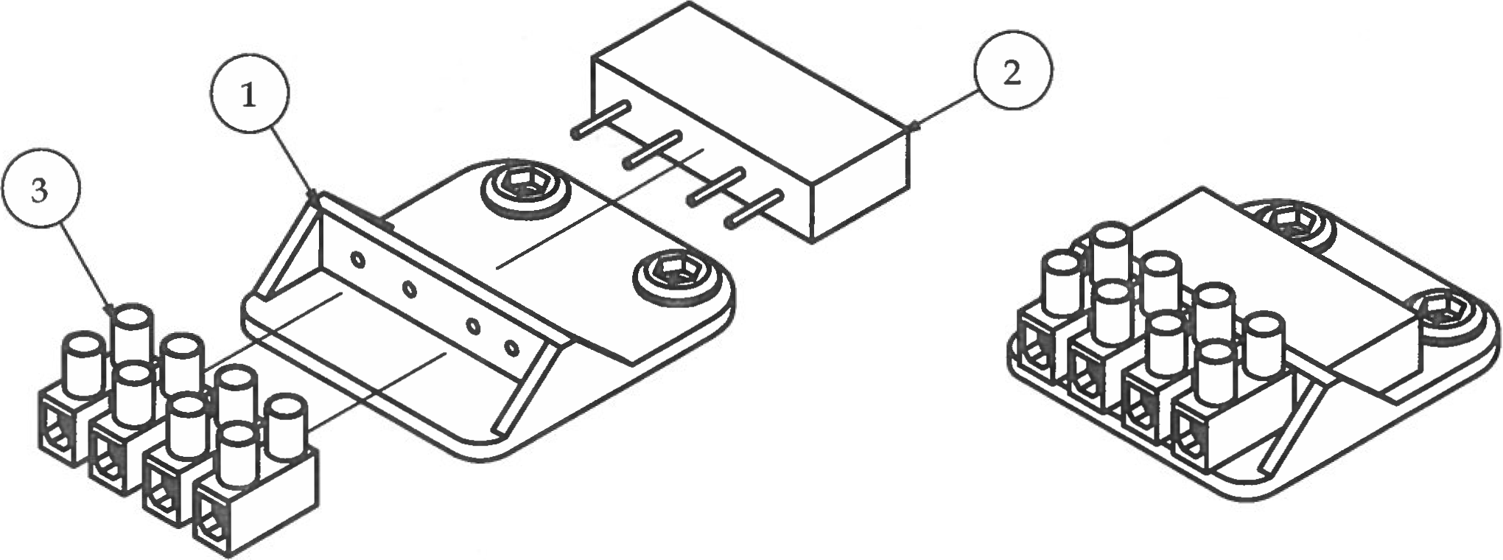

|  |  |  |  |
| --- | --- | --- | --- |
| **PARTS LIST** | | | |
| **ITEM** | **QTY** | **PART NUMBER** | **DESCRIPTION** |
| 1 | 1 | ssRelayBrktV3 | 3D printed part |
| 2 | 1 | solidStateRelay | Off-the-shelf components |
| 3 | 2 | euroConnector | Electrical component |
|  |  | Micro Flathead Screwdriver | Tools |

# Electronics Tray Sub-Assembly

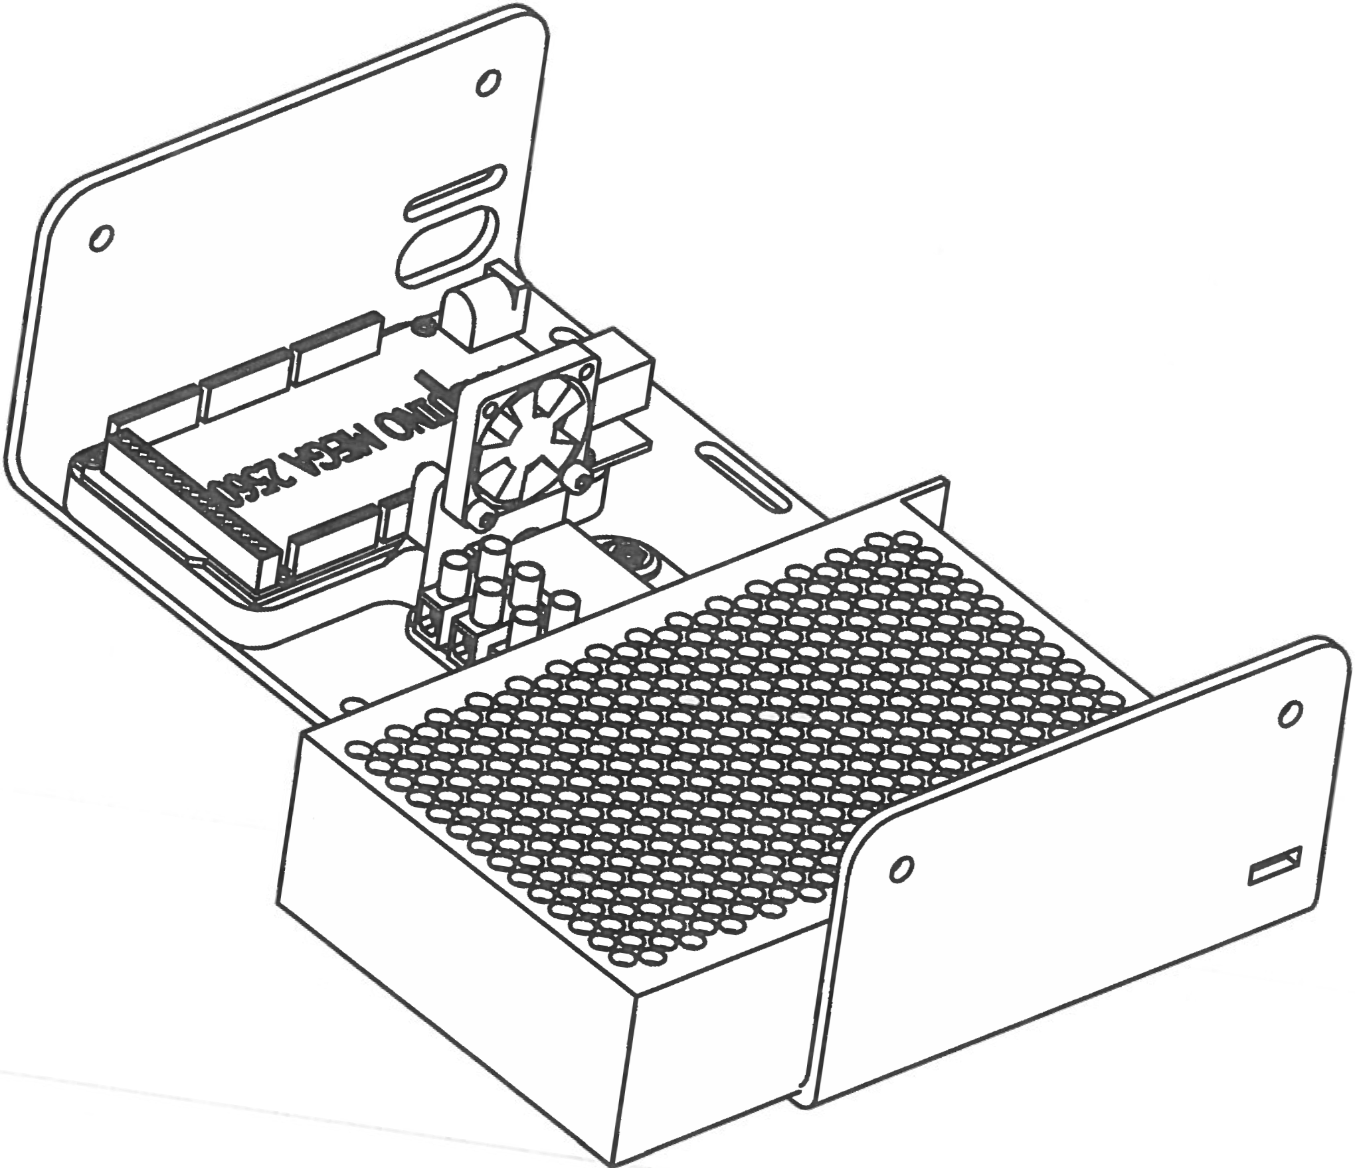

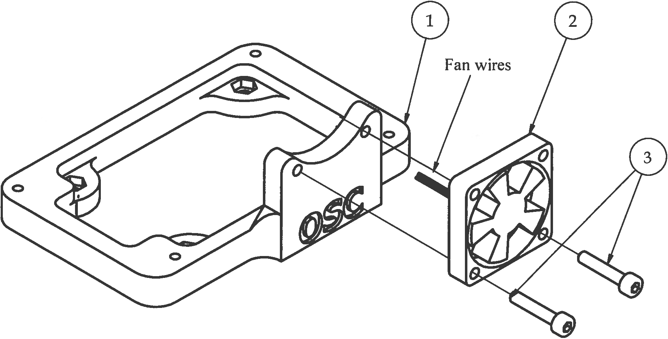Step 1

1. Attach the cooling fan to the RAMPs bracket. Make sure that the wires from the fan are sticking out from the lower comer and toward the back of the RAMPs bracket as shown in the picture. Bolts will self-tap into the plastic. DO NOT over tighten.

|  |  |  |  |
| --- | --- | --- | --- |
| **PARTS LIST** | | | |
| **ITEM** | **QTY** | **PART NUMBER** | **DESCRIPTION** |
| 1 | 1 | RAMPsBracketV2 | 3D printed part |
| 2 | 1 | 30mm Box Fan | Electrical component |
| 3 | 2 | M3 x 16 | Nuts and bolts |
|  |  | M2.5 Hex Wrench | Tools |

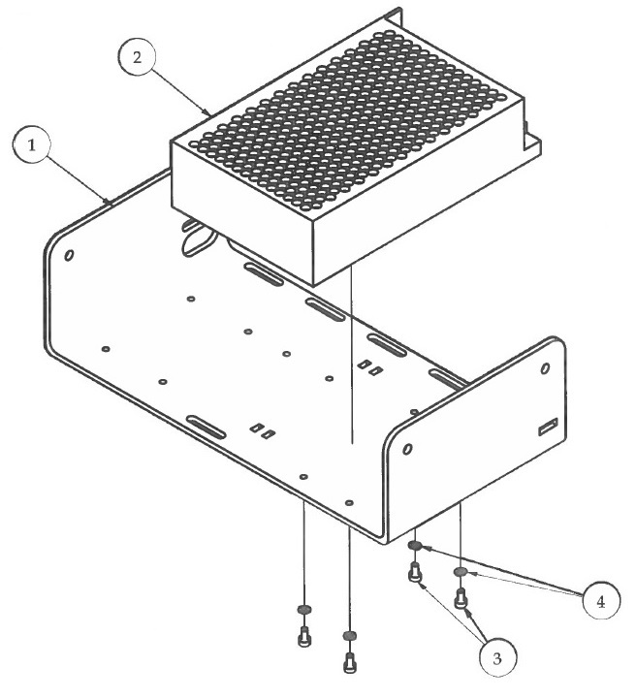Step 2

|  |  |  |  |
| --- | --- | --- | --- |
| **PARTS LIST** | | | |
| **ITEM** | **QTY** | **PART NUMBER** | **DESCRIPTION** |
| 1 | 1 | ElectronicsTray_AL | Custom aluminum part |
| 2 | 1 | 12v 60W power supply | Off-the-shelf component |
| 3 | 4 | M3 x 6 | Nuts and bolts |
| 4 | 4 | M3 Washer | Nuts and bolts |
|  |  | M2.5 Hex Wrench | Tools |

1. Attach the power supply to the electronics tray as shown in the picture.

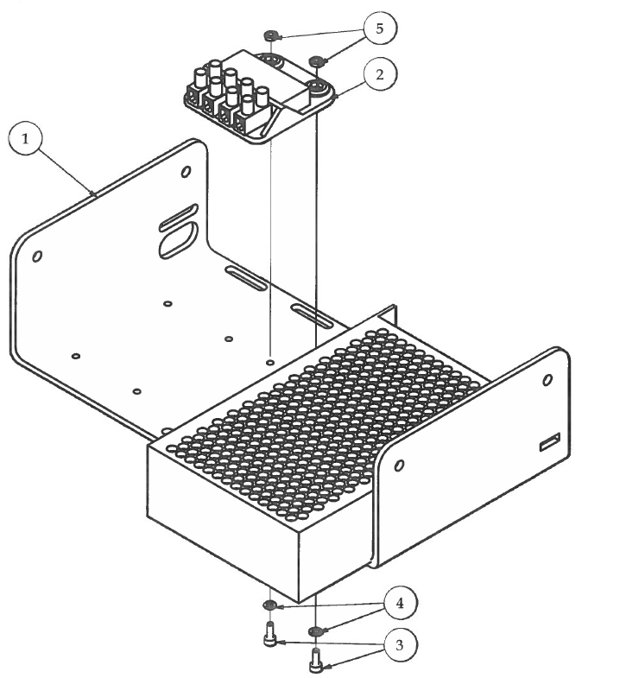Step 3

1. Attach Solid State Relay bracket to electronics tray.

|  |  |  |  |
| --- | --- | --- | --- |
| **PARTS LIST** | | | |
| **ITEM** | **QTY** | **PART NUMBER** | **DESCRIPTION** |
| 1 | 1 | Step 2 | Previous sub-assembly |
| 2 | 1 | SSRelay Sub-Assembly | Previous sub-assembly |
| 3 | 2 | M3 x 10 | Nuts and bolts |
| 4 | 2 | M3 Washer | Nuts and bolts |
| 5 | 2 | M3 Hex Nut | Nuts and bolts |
|  |  | M2.5 Hex Wrench | Tools |

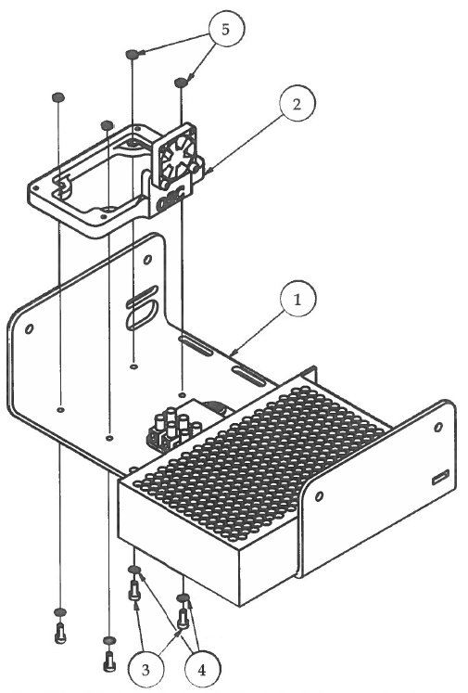Step 4

1. Attach the RAMPs bracket sub-assembly to the electronics tray. Make sure the fan is positioned toward the center of the tray.

|  |  |  |  |
| --- | --- | --- | --- |
| **PARTS LIST** | | | |
| **ITEM** | **QTY** | **PART NUMBER** | **DESCRIPTION** |
| 1 | 1 | Step 3 | Previous sub-assembly |
| 2 | 1 | Step 1 | Previous sub-assembly |
| 3 | 4 | M3 x 10 | Nuts and bolts |
| 4 | 4 | M3 Washer | Nuts and bolts |
| 5 | 4 | M3 Hex Nut | Nuts and bolts |
|  |  | M2.5 Hex Wrench | Tools |

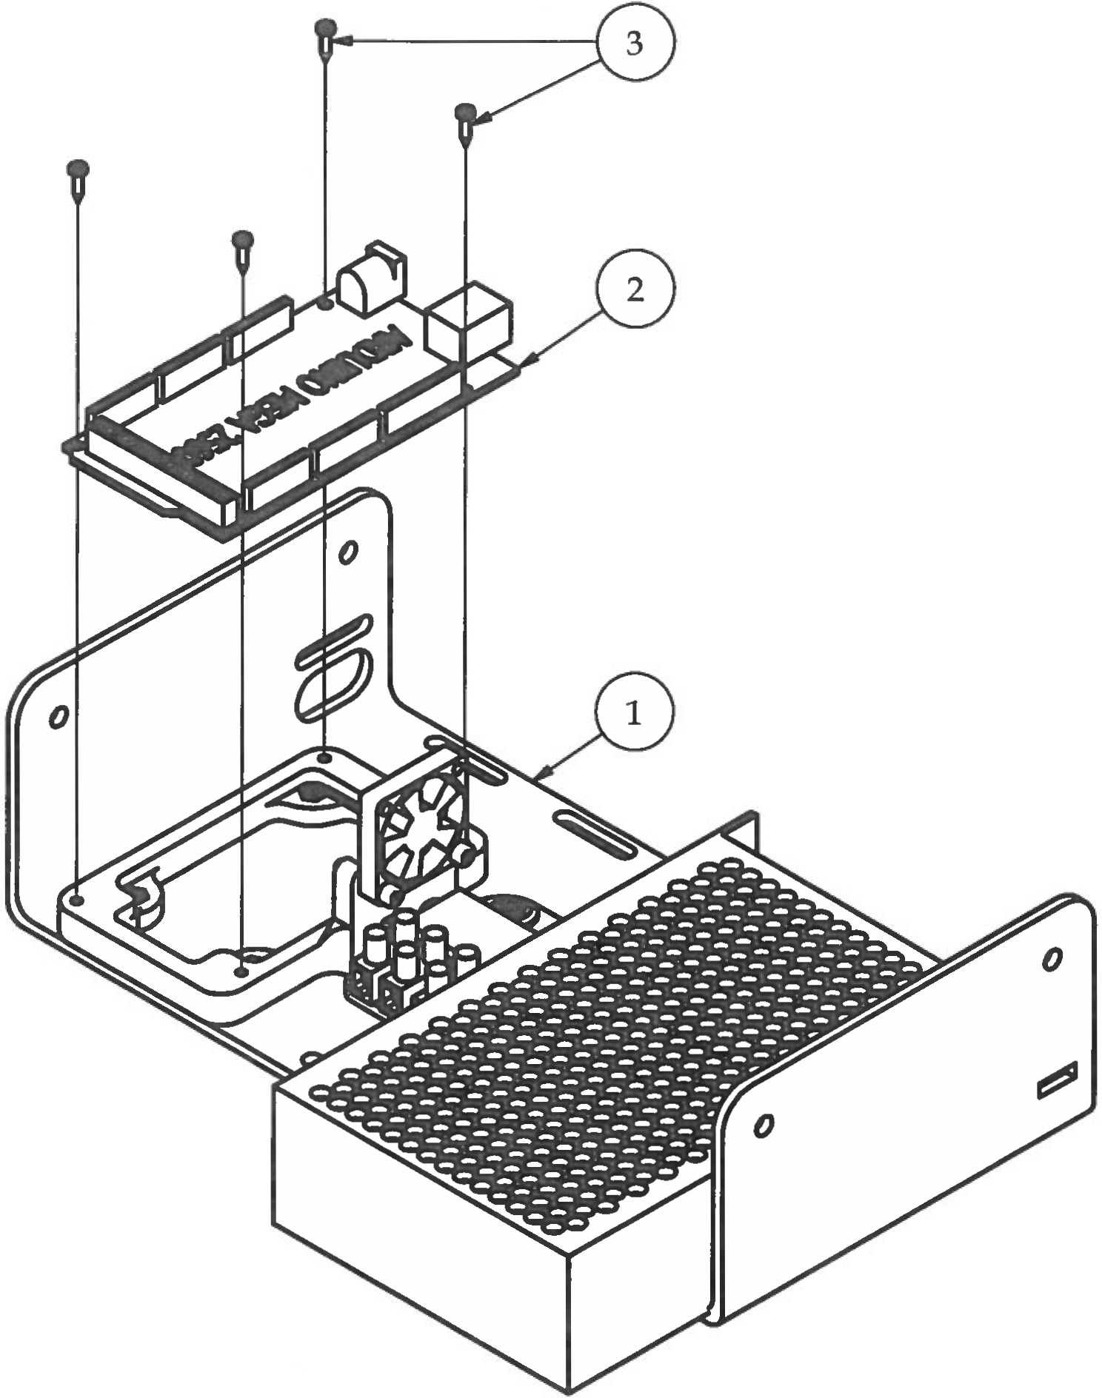Step 5

|  |  |  |  |
| --- | --- | --- | --- |
| **PARTS LIST** | | | |
| **ITEM** | **QTY** | **PART NUMBER** | **DESCRIPTION** |
| 1 | 1 | Step 4 | Previous sub-assembly |
| 2 | 1 | ArduinoMega2560 | Off-the-shelf component |
| 3 | 4 | #2 x 3/8 | Nuts and bolts |
|  |  | Micro Phillips Screwdriver | Tools |

1. Attach the Arduino to the RAMPs bracket with the USB port facing to the back. Arduino should be secure on the bracket but be careful to not over tighten the screws to where the circuit board is bending.

# Electronics Tray Pre-Wiring Guide

Pre-wiring of Electronics Tray:

1. Finish electronics tray sub-assembly

2. Refer to the Wire Kit Part Identification Key in the back of the manual to help identify the correct wires to use.

3. Start with DC to RAMPs power wire

a. Fork terminal ends will be secured into the 12V DC+ and- terminals on the 12V power supply (red is +, black is -) ***TIP - Use the flat head screwdriver on the power supply to get a better grip on the terminal screws.

b. Run wires along edge of tray and insert green plug into RAMPs power port

c. Secure wire to the tray using 2 small zip ties on outer edges of wire creating a clean install

4. AC SS Relay Wire

a. Fork terminal ends will go into the AC terminals on the power supply (I believe that the red wire is the one that is stripped and tinned on the other end and the black wire has a blue butt splice connector on the other end)

b. The red wire should be secured into the "L" (live) terminal and the black wire should be secured into the "N" (neutral) terminal. ***TIP- face the fork terminals down to make adding the other fork terminals from the GFCI wall plug wire easier when you get to the final wiring stages of the printer.

c. DO NOT SECURE with zip ties yet. Wait until step 7.

5. Bed Grounding Wire

a. Fork terminal end secured into the “ " (ground) terminal on the power supply.

b. ***TIP -Also face this fork terminal down.

6. DC Bed Heater Control Wire

a. On the back of the RAMPs shield are the power output terminals. Locate the 2-port power terminal labeled D8.

b. Secure one end of the DC Bed Heater Control Wire into the + and - D8 terminals taking note of which color of the wire is going into positive and negative. (the two colors of DC Bed Heater Control Wire may vary from printer to printer)

7. To make for a clean wire install, group all wires from the last 3 steps together and run from the back of electronics tray to the front in the gap between the power supply and the solid state relay bracket.

a. Using small zip ties, start by securing wires to the back of electronics tray first

b. Then with grouping the 3 wires together (AC SS Relay wire, Bed Grounding Wire, and the DC Bed Heater Control wire) secure them to the electronics tray with small zip ties using the 2 pairs of small rectangular holes strategically placed on the electronics tray.

8. Wiring the Solid State Relay (SS Relay)

a. LOOK at the Solid State Relay and read the information provided. Locate the numbered ports 1-4 for ease of install.

b. AC SS Relay wire - the Live (L) wire that is stripped and tinned goes into port 1. The neutral (N) wire with the butt splice attached will not be connected until after heated bed is installed and connected to one of the wires from the heat pad.\

c. DC Bed Heater Control Wire—The positive wire (+) goes into port 3 and the negative wire goes into port 4.

d. Electronics Tray sub-assembly wiring is now complete. Leave the rest of the wires until much later when you are completing the final wiring of the entire after heated bed has been installed.

9. To finish wiring the heated bed after the flexMendel has been assembled:

a. Bed Thermistor Wire - has a 2-pin female connector attached to the end, plugs into the male pins on the RAMPs shield labeled Tl.

b. One wire from the heat pad on the bed goes into port 2 on the solid state relay, and the other should be crimped into the open end of the blue butt splice on the AC SS Relay wire.

c. Install the bed grounding wire to the heated bed by securing the ring terminal to the wire post in between the lock nut and the bedplate located in the front right corner.

d. Run all wires from the heated bed (bed thermistor and heat pad wires) around the front of the wire post and secure tightly with a small zip tie to prevent bed movement from tugging on the wire connections. If not secured properly, over time the back and forth movement of the bed will eventually dislodge the wire connections inside the heat pad and you will have to buy a new one (not cheap ~ $75).

e. Using small zip ties, tightly secure all wires to the heated bed with the slot in front of the SS Relay on the electronics tray to prevent bed movement from tugging on wire connections.

10. Pictures and additional wiring information can be found in the "Electrical Assembly" section of the manual.

# X-Stage Supports Sub-Assembly

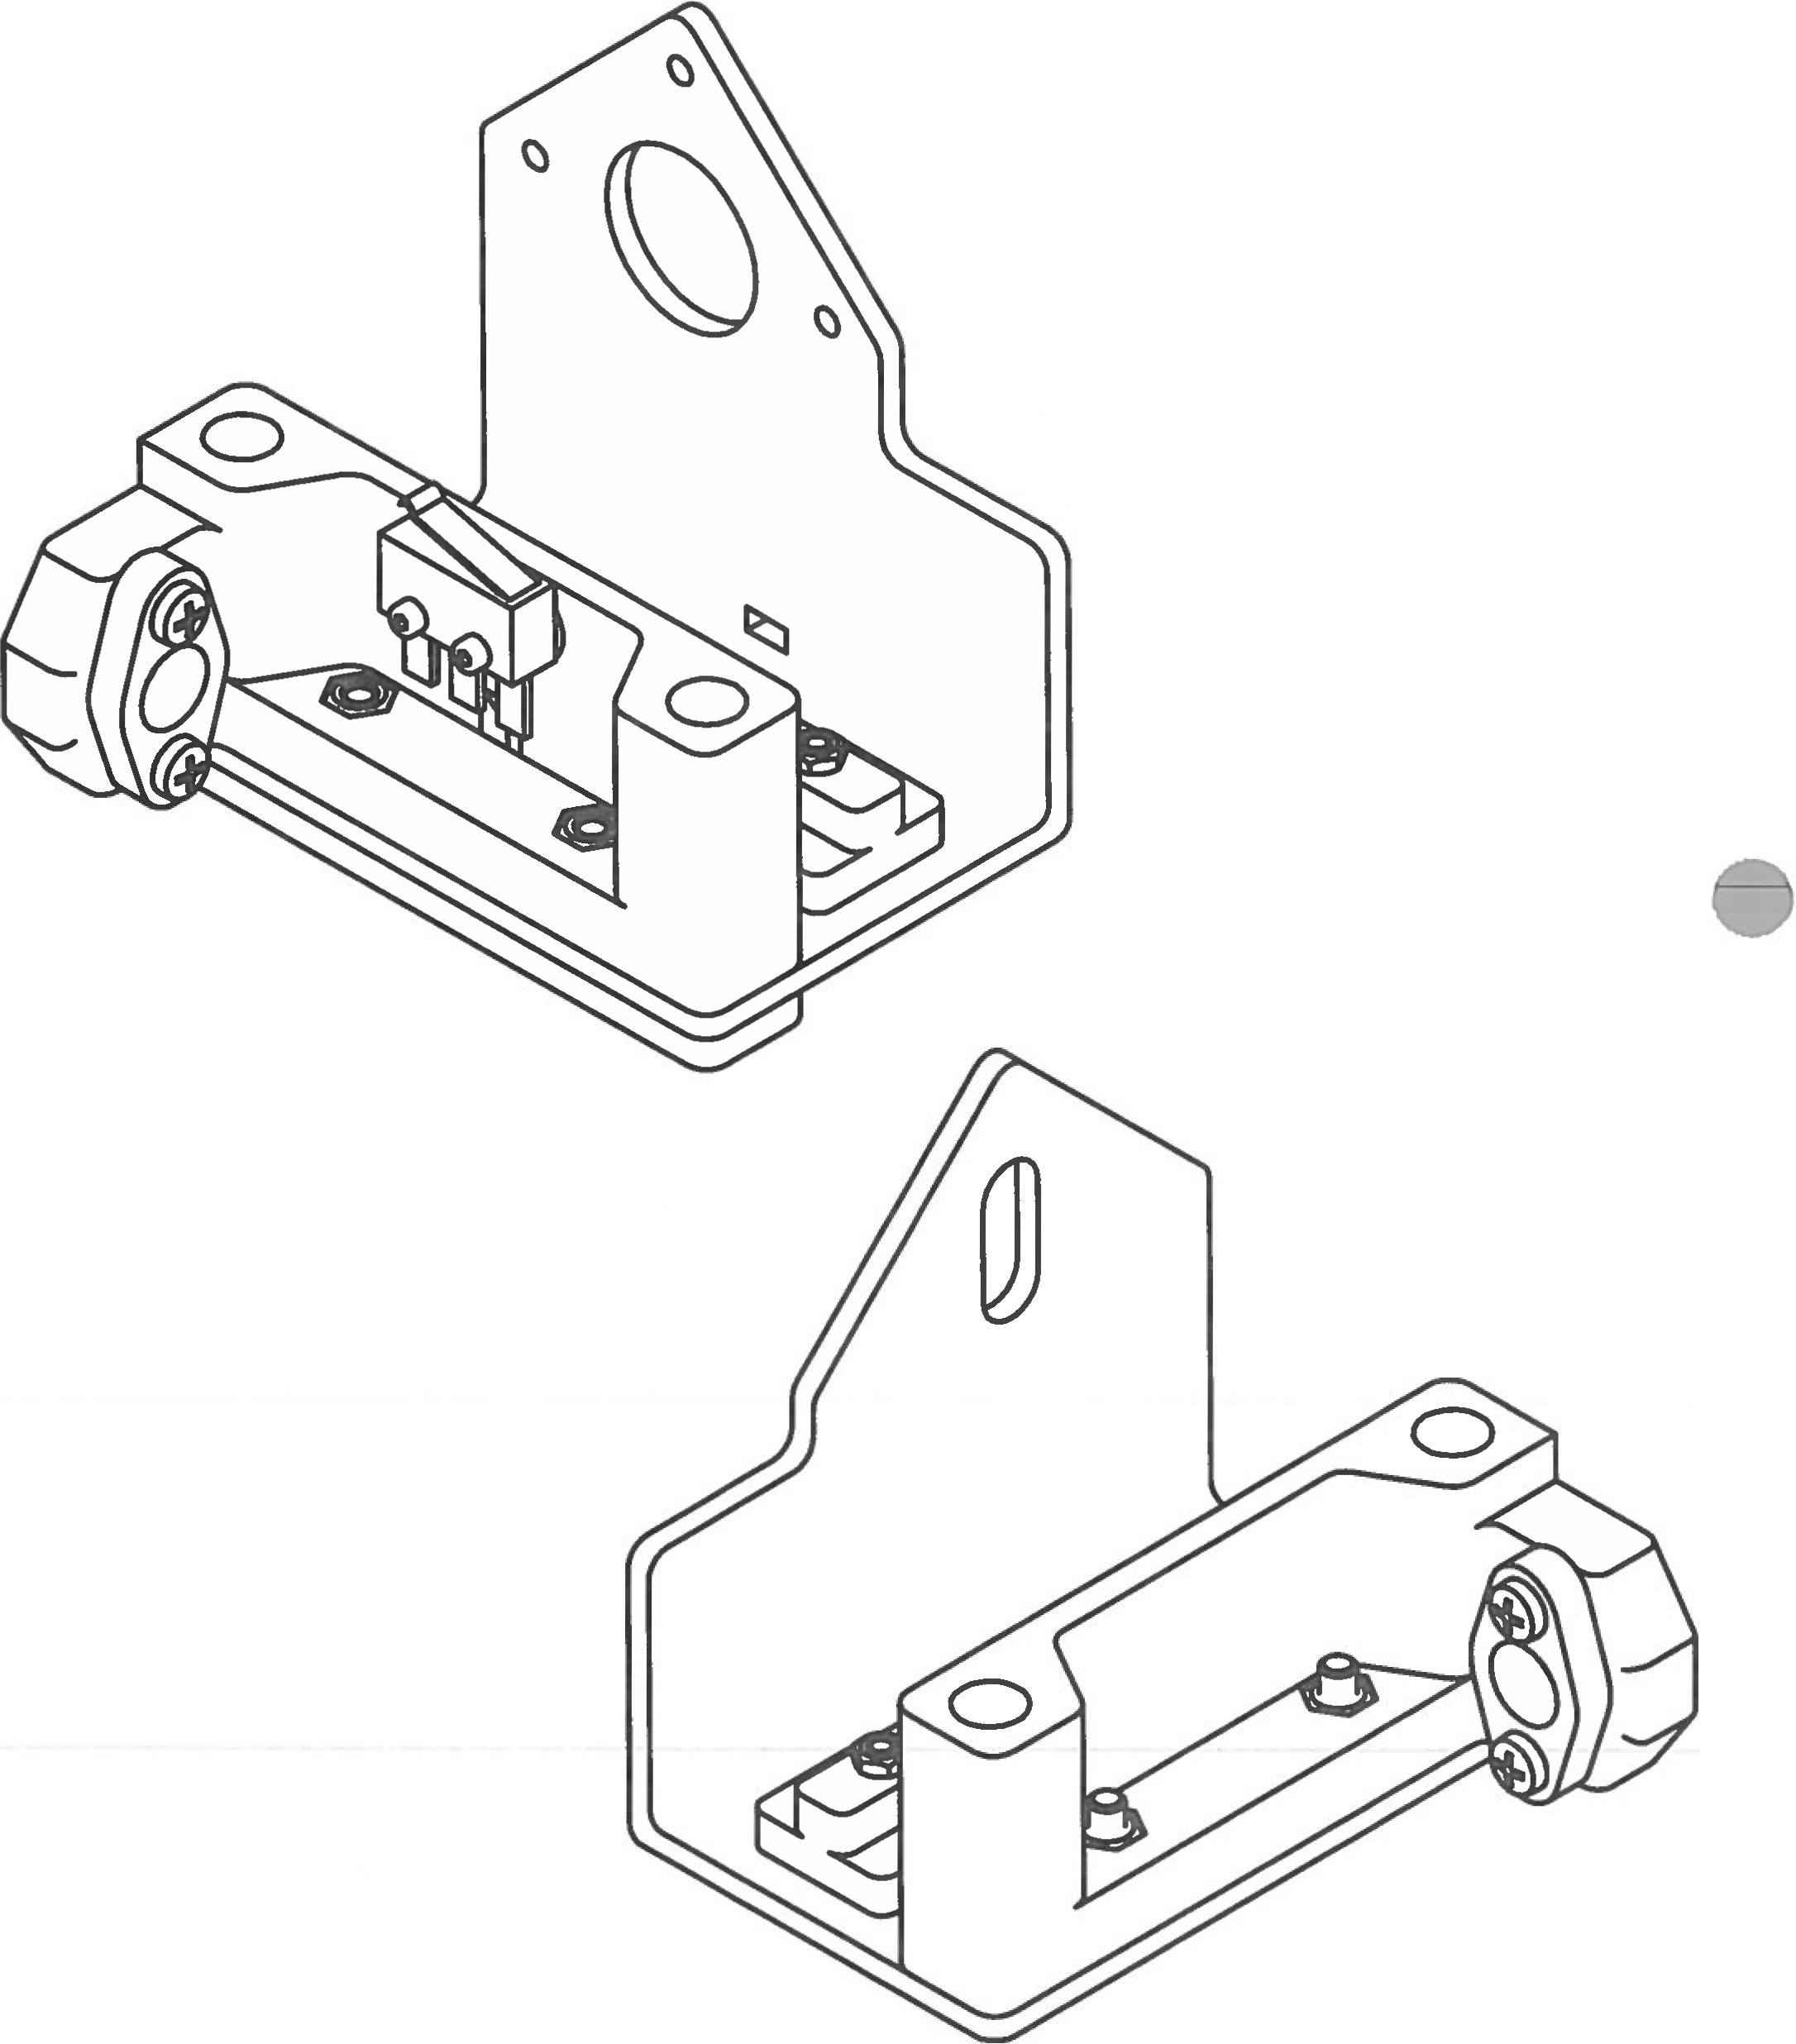

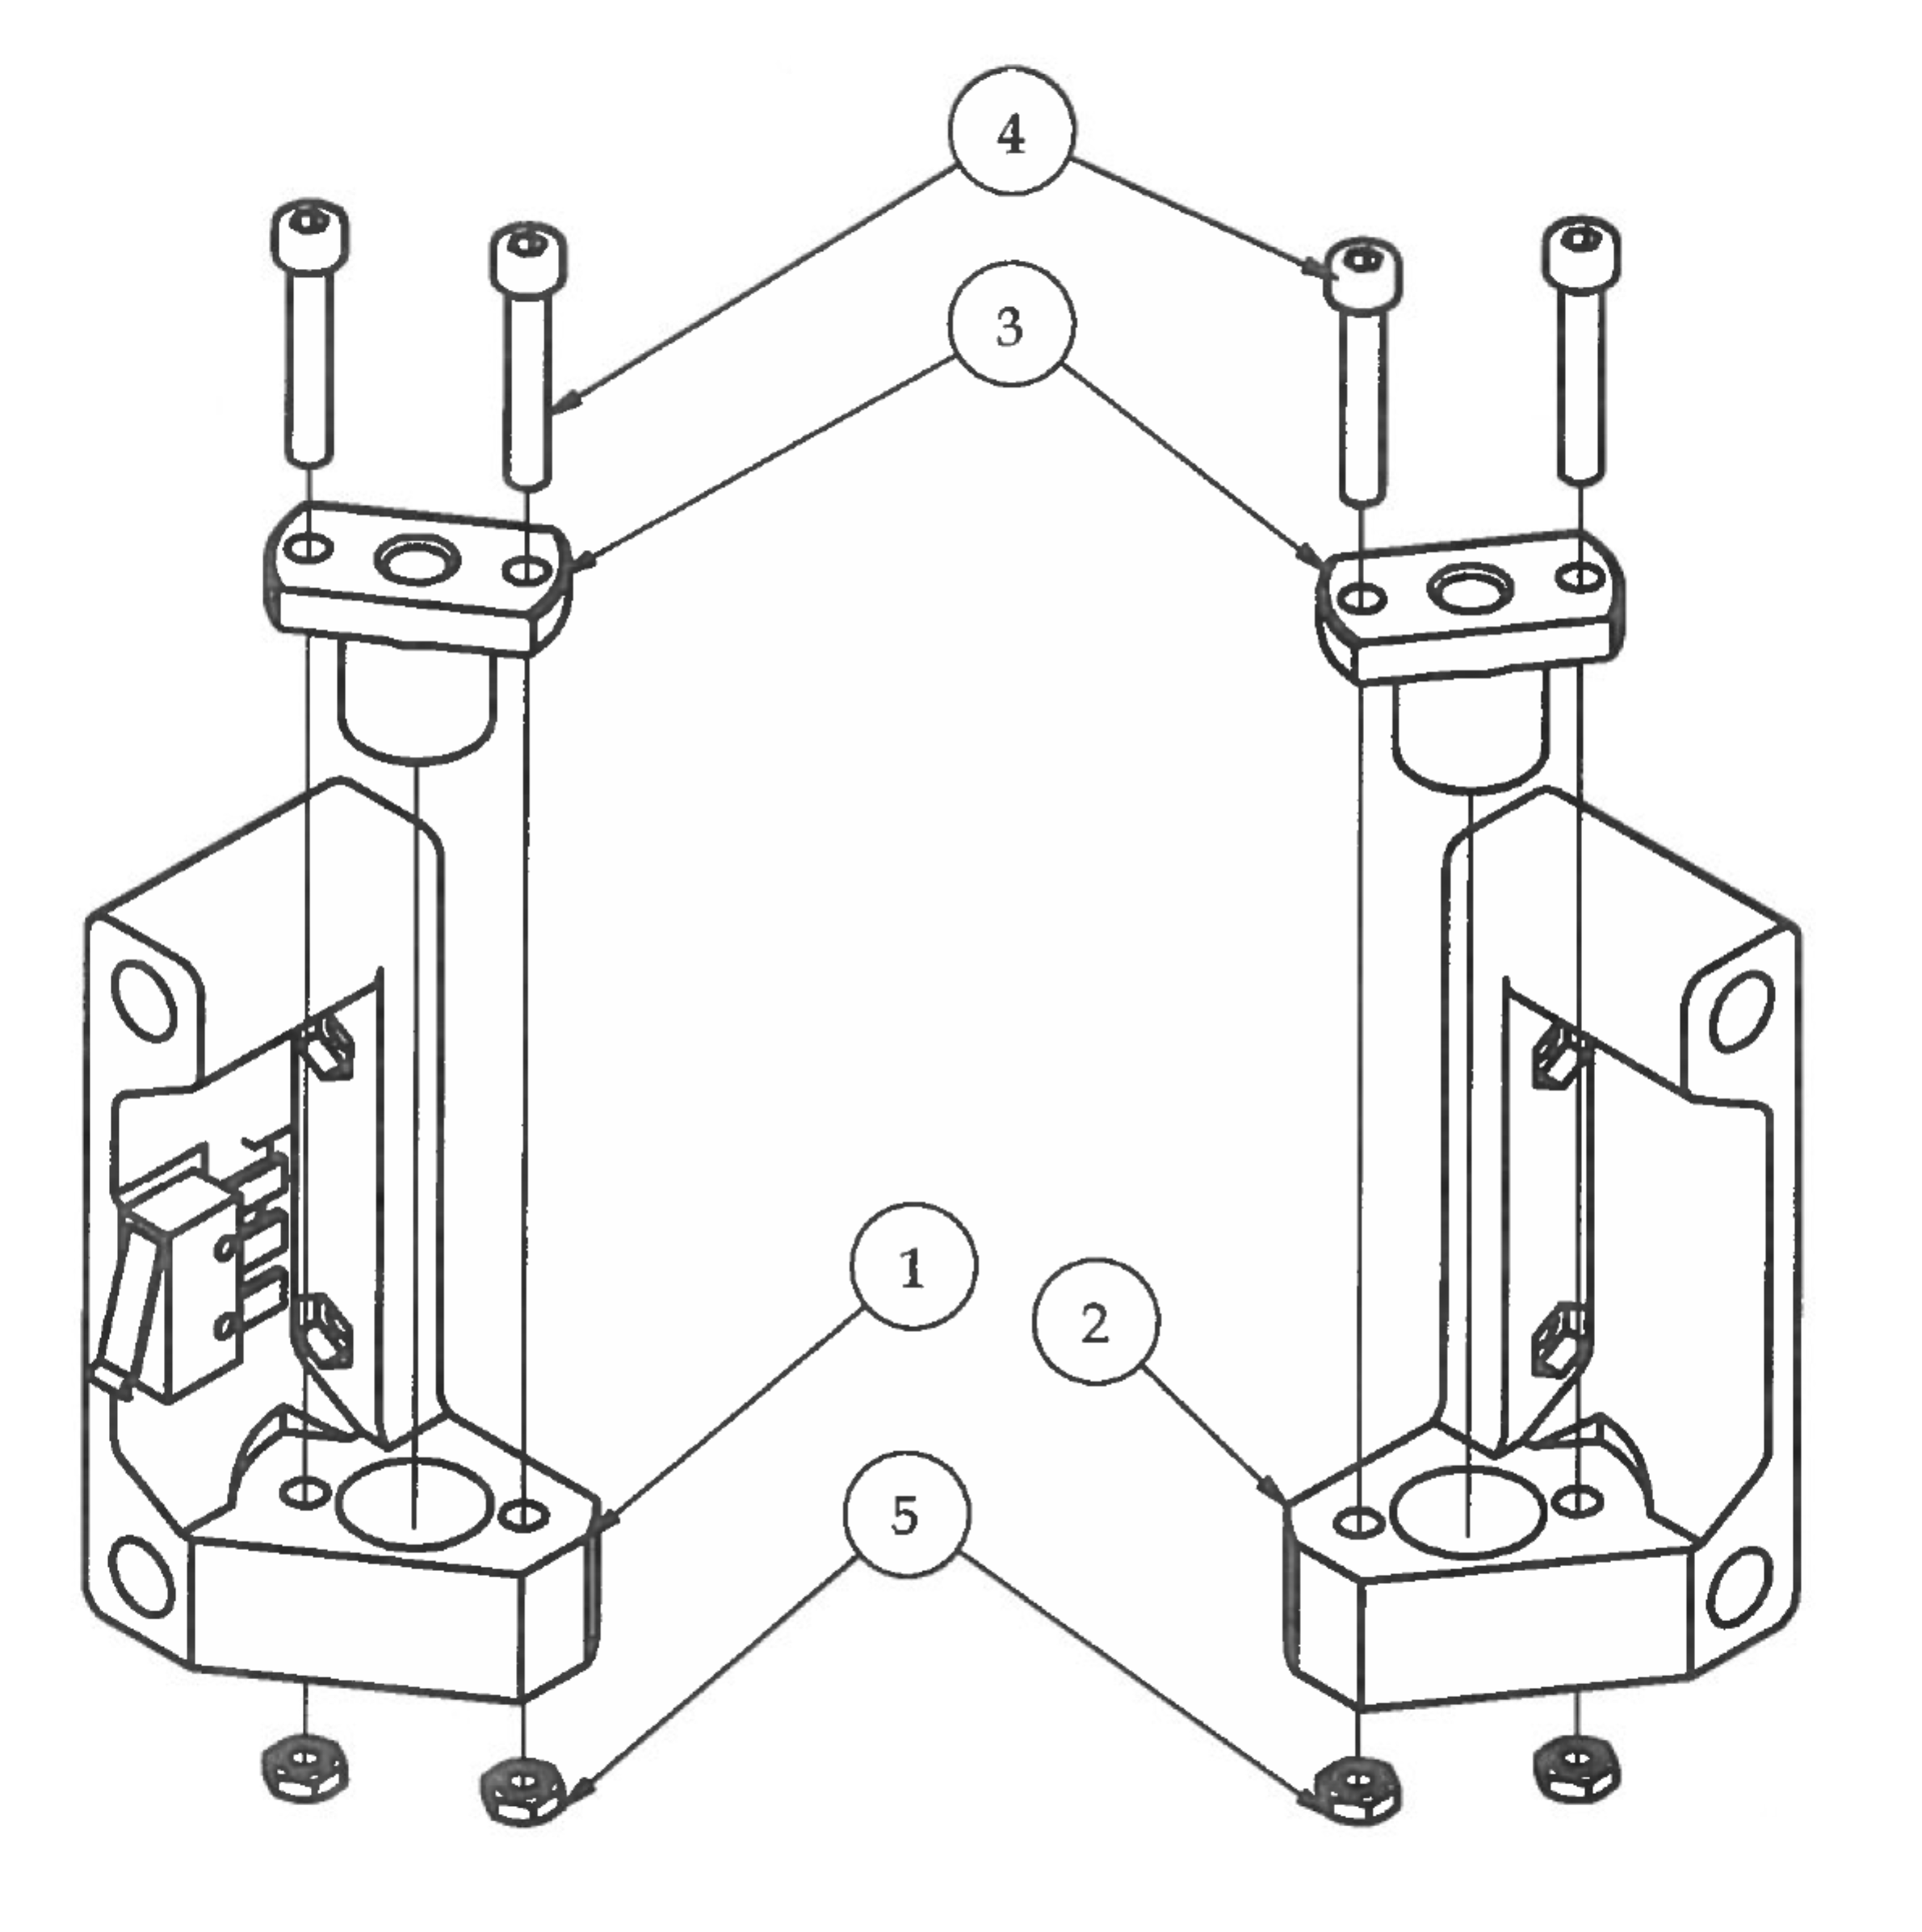Step 1

1. Secure M8 Lead Screw Nuts inside cavity on xRodSupportMotor and xRodSupport brackets with M4 hardware.

2. DO NOT OVER TIGHTEN!!*** This will prevent the Z axis from over-constraining. ***

|  |  |  |  |
| --- | --- | --- | --- |
| **PARTS LIST** | | | |
| **ITEM** | **QTY** | **PART NUMBER** | **DESCRIPTION** |
| 1 | 1 | xRodSupportMotorV5 | 3D printed part |
| 2 | 1 | xRodSupportV5 | 3D printed part |
| 3 | 2 | 8mm Lead Screw Nut | Nuts and bolts |
| 4 | 4 | M4 x 25 | Nuts and bolts |
| 5 | 4 | M4 Hex Nut | Nuts and bolts |
|  |  | M3 Hex Wrench | Tools |
|  |  | Micro Pliers | Tools |

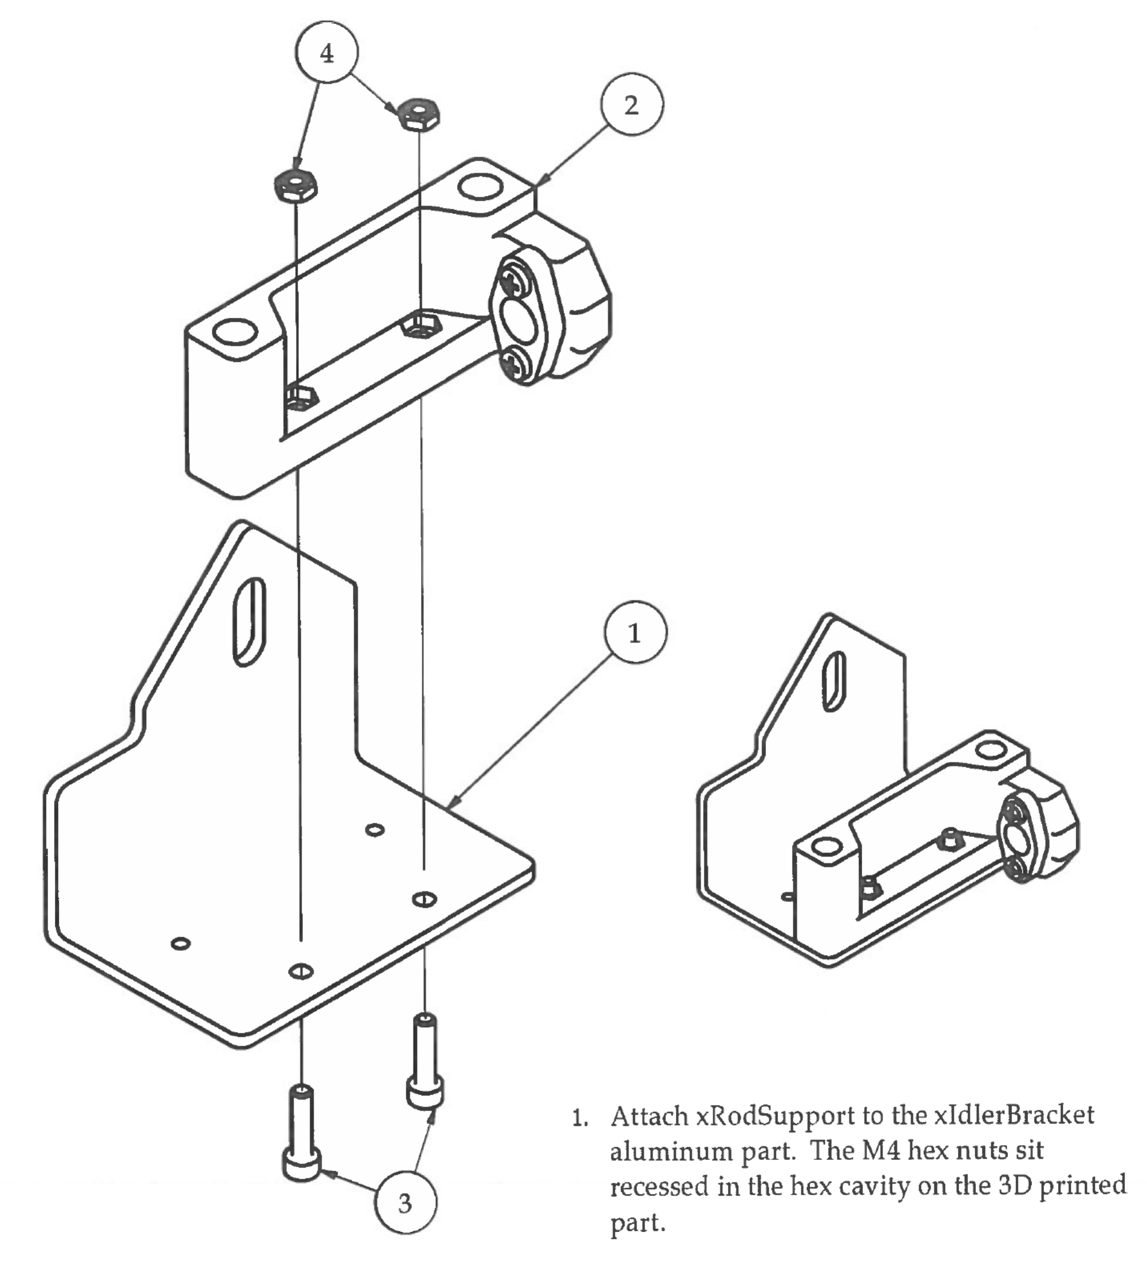Step 2

|  |  |  |  |
| --- | --- | --- | --- |
| **PARTS LIST** | | | |
| **ITEM** | **QTY** | **PART NUMBER** | **DESCRIPTION** |
| 1 | 1 | xIdlerBracket_AL | Custom aluminum part |
| 2 | 1 | Step 1.2 | Precious sub-assembly |
| 3 | 2 | M4 x 16 | Nuts and bolts |
| 4 | 2 | M4 Hex Nut | Nuts and bolts |
|  |  | M3 Hex Wrench | Tools |

Step 3

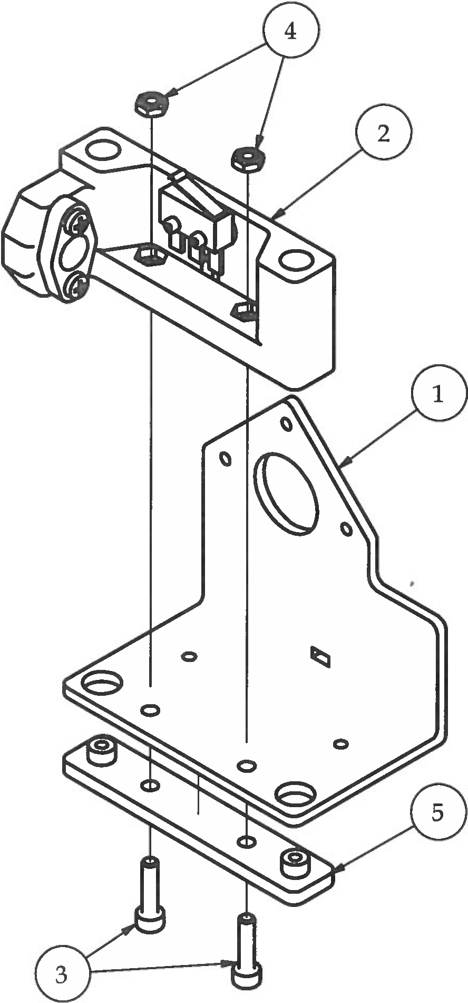

1. Attach the xRodSupportMotor and the smoothRodLock to the xMotorBracket aluminum part with the M4 x 16 bolts and M4 hex nuts.

2. Make sure that the wires from the X limit switch are going through the small rectangular hole on the 3D printed part AND through the small rectangular hole on the aluminum part.

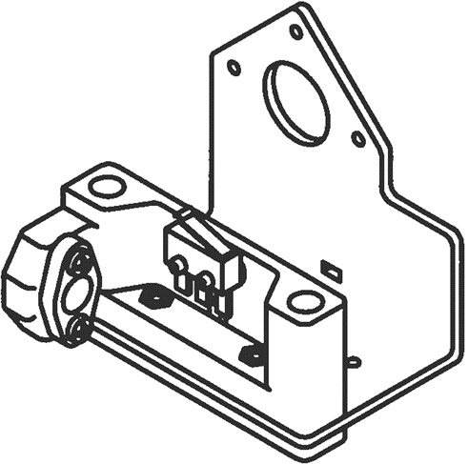

|  |  |  |  |
| --- | --- | --- | --- |
| **PARTS LIST** | | | |
| **ITEM** | **QTY** | **PART NUMBER** | **DESCRIPTION** |
| 1 | 1 | xMotorBracket_AL | Custom aluminum part |
| 2 | 1 | Step 1.1 | Previous sub-assembly |
| 3 | 2 | M4 x 16 | Nuts and bolts |
| 4 | 2 | M4 Hex Nut | Nuts and bolts |
| 5 | 1 | smoothRodLock | 3D printed part |
|  |  | M3 Hex Wrench | Tools |

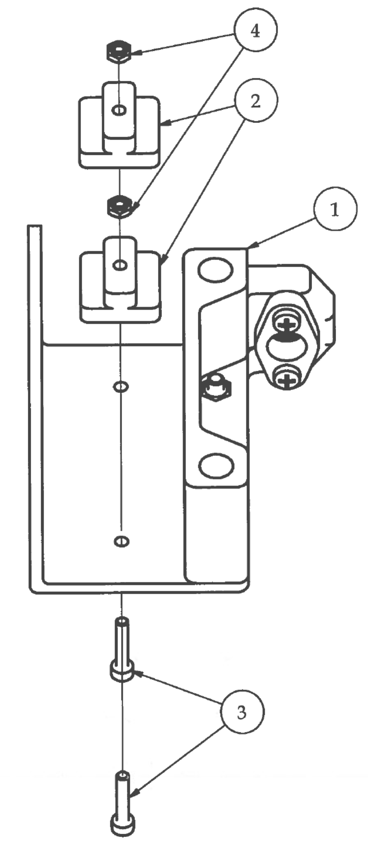Step 4

1. Mount 2 Z Slides onto aluminum plate as shown using M3 x 16 bolt and M3 hex nut. Allow for small rotational movement initially.

2. Place the slide assembly into the marked slot on the 450mm extrusion. Test smoothness of slides by moving back and forth in the extrusion.

3. Slowly tighten the M3 x 16 bolts trying to keep the slides in alignment. DO NOT over tighten or this will cause the UHMW slides to bow and restrict movement.

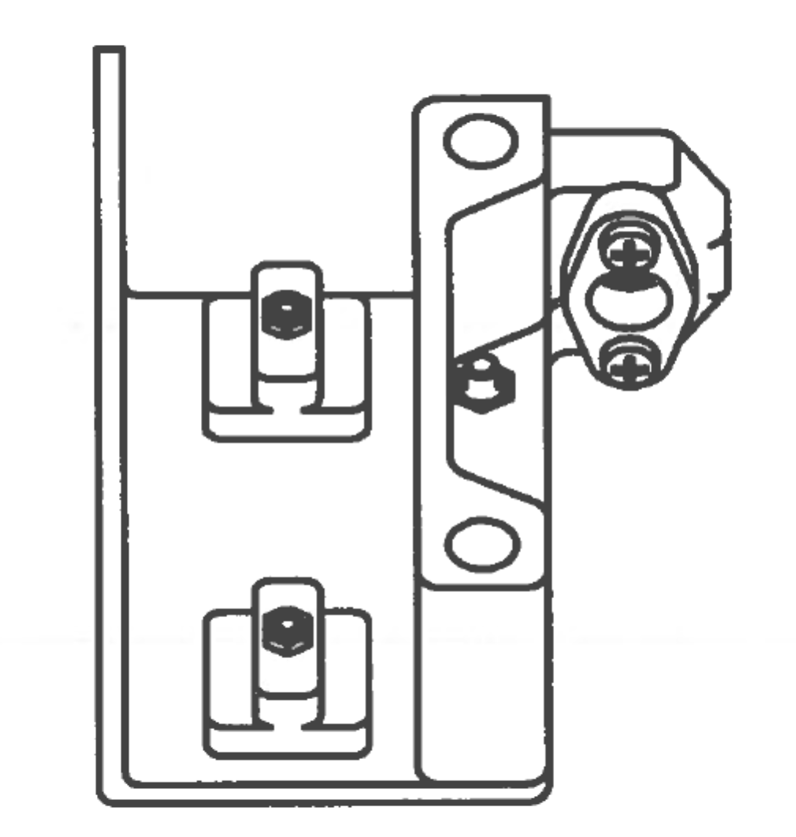4. After tightening completely, double check slides in 450mm extrusion for smoothness. The slides should be able to move back and forth in the slots with ease. If you cannot slide the sub­ assembly back and forth with ease, double check to make sure you are placing them into the right slot. If still having trouble, go back and repeat steps 1-4 on this page.

|  |  |  |  |
| --- | --- | --- | --- |
| **PARTS LIST** | | | |
| **ITEM** | **QTY** | **PART NUMBER** | **DESCRIPTION** |
| 1 | 1 | Step 2 | Previous sub-assembly |
| 2 | 2 | zSlide | Custom CNC milled part |
| 3 | 2 | M3 x 16 | Nuts and bolts |
| 4 | 2 | M3 Hex Nut | Nuts and bolts |
|  |  | M2.5 Hex Wrench | Tools |

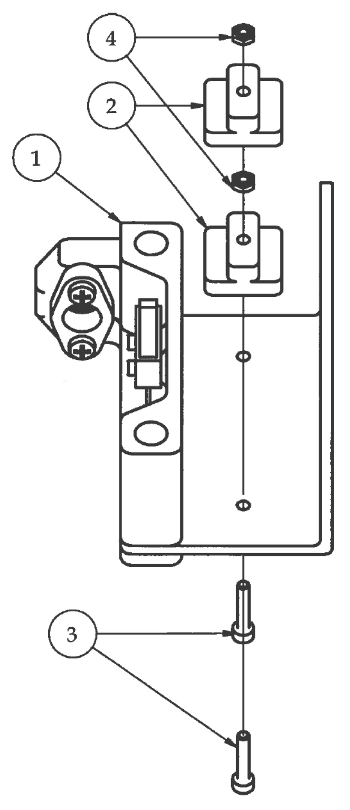Step 5

1. Using a small piece of electrical tape, secure the limit switch wire to the aluminum bracket to keep it from potentially rubbing on the aluminum extrusion.

2. Mount 2 Z Slides onto aluminum plate as shown using M3 x 16 bolt and M3 hex nut. Allow for small rotational movement initially.

3. Place the slide assembly into the marked slot on the 450mm extrusion. Test smoothness of slides by moving back and forth in the extrusion.

4. Slowly tighten the M3 x 16 bolts trying to keep the slides in alignment. DO NOT over tighten or this will cause the UHMW slides to bow and restrict movement.

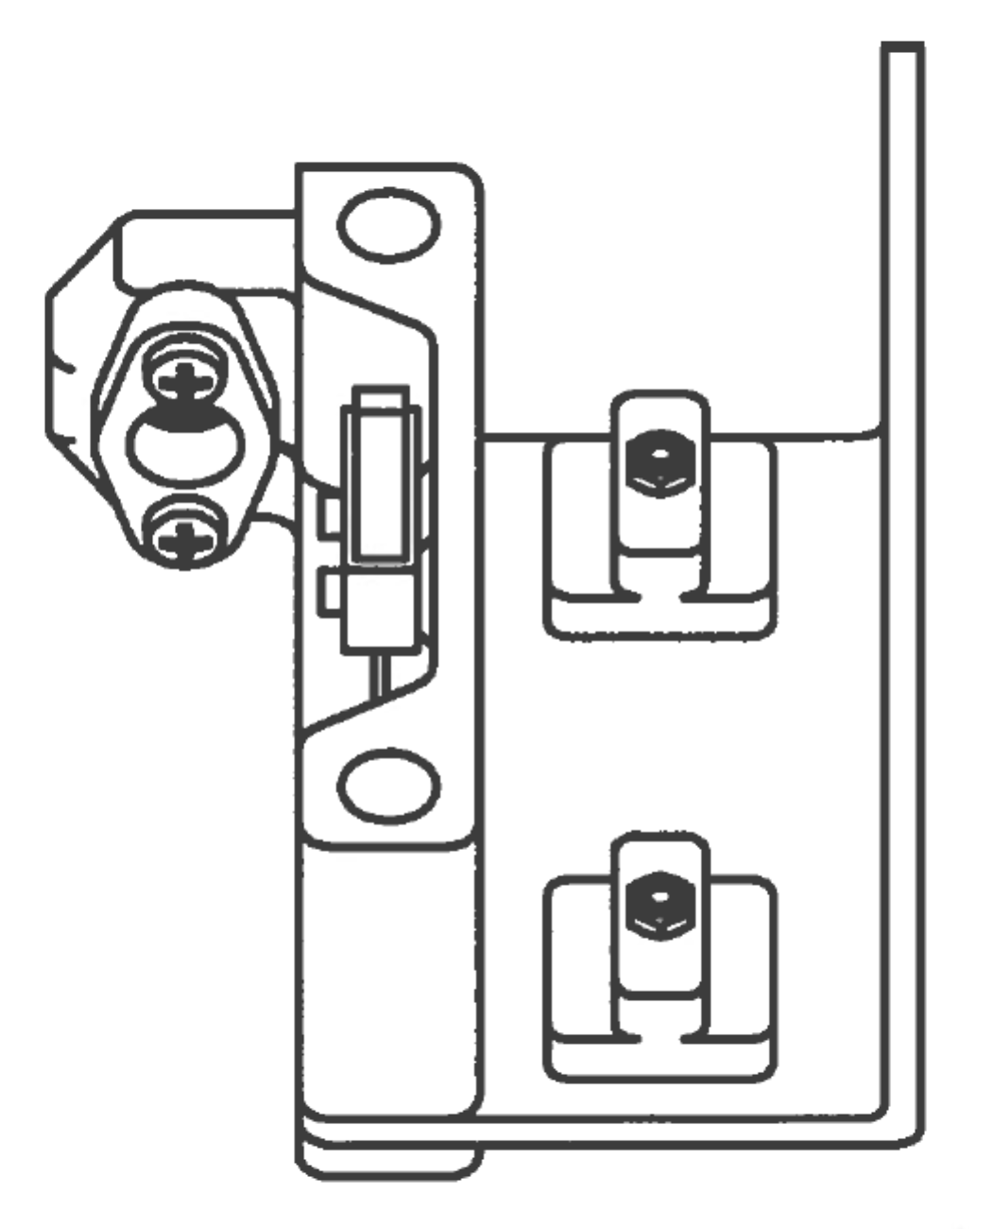5. After tightening completely, double check slides in 450mm extrusion for smoothness. The slides should be able to move back and forth in the slots with ease. If you cannot slide the sub-assembly back and forth with ease, double check to make sure you are placing them into the right slot. If still having trouble, go back and repeat steps 1-4 on this page.

|  |  |  |  |
| --- | --- | --- | --- |
| **PARTS LIST** | | | |
| **ITEM** | **QTY** | **PART NUMBER** | **DESCRIPTION** |
| 1 | 1 | Step 3 | Previous sub-assembly |
| 2 | 2 | Zslide | Custom CNC milled part |
| 3 | 2 | M3 x 16 | Nuts and bolts |
| 4 | 2 | M3 Hex Nut | Nuts and bolts |
|  |  | M2.5 Hex Wrench | Tools |

# Z Rod Supports Sub-Assembly

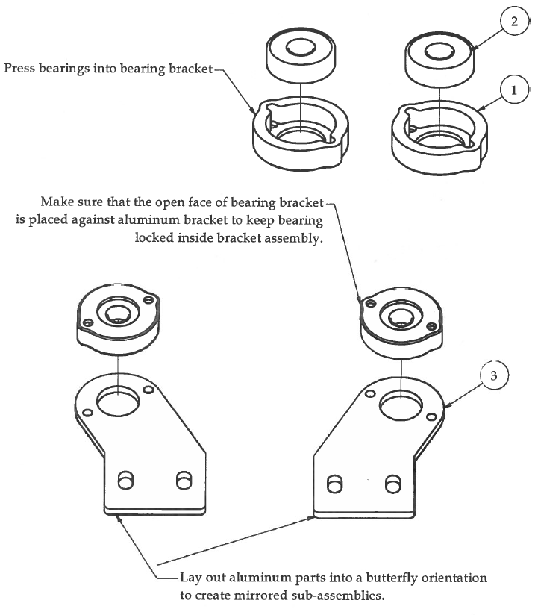Step 1

|  |  |  |  |
| --- | --- | --- | --- |
| **PARTS LIST** | | | |
| **ITEM** | **QTY** | **PART NUMBER** | **DESCRIPTION** |
| 1 | 2 | zBearingHousing | 3D printed part |
| 2 | 2 | 608zz Bearing | Off-the-shelf component |
| 3 | 2 | zRodBearingBracket_AL | Custom aluminum part |

Step 2

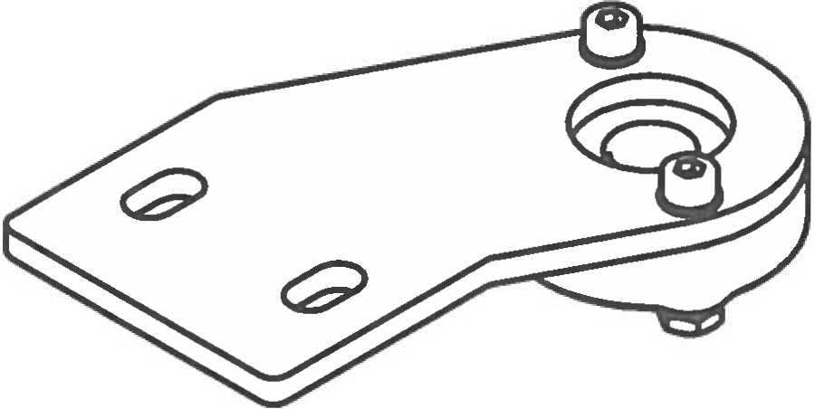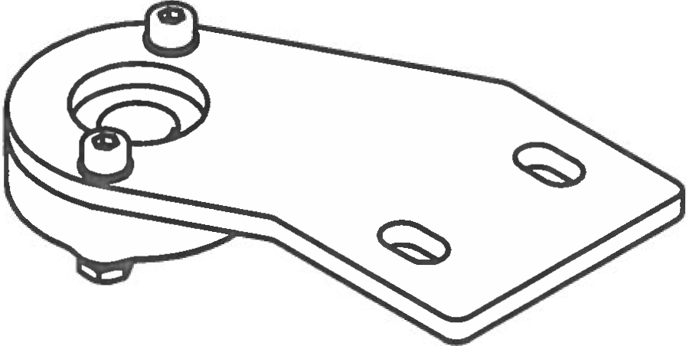

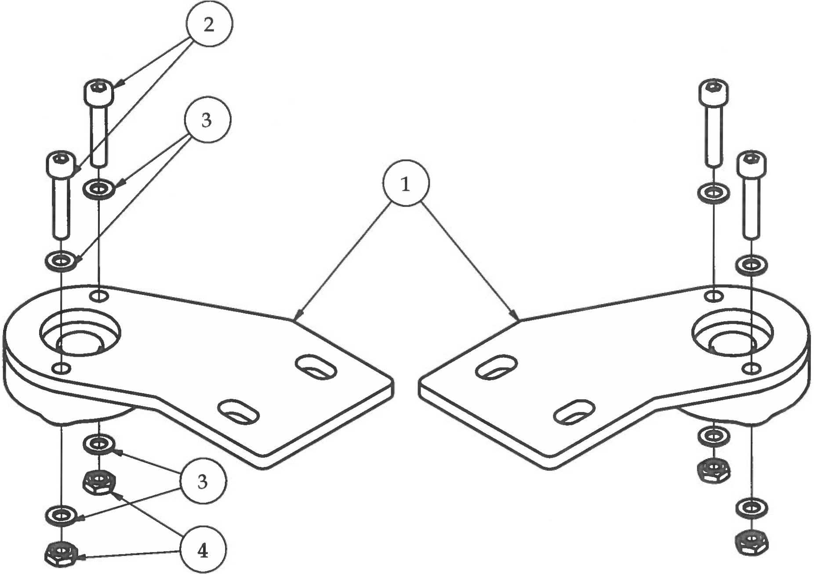

|  |  |  |  |
| --- | --- | --- | --- |
| **PARTS LIST** | | | |
| **ITEM** | **QTY** | **PART NUMBER** | **DESCRIPTION** |
| 1 | 2 | Step 1 | Previous sub-assembly |
| 2 | 4 | M3 x 16 socket head screw | Nuts and bolts |
| 3 | 8 | M3 Washer | Nuts and bolts |
| 4 | 4 | M3 Hex Nut | Nuts and bolts |
|  |  | M2.5 Hex Wrench | Tools |
|  |  | Micro Pliers | Tools |

# Low-Mass Extruder Assembly

Step 1

1. 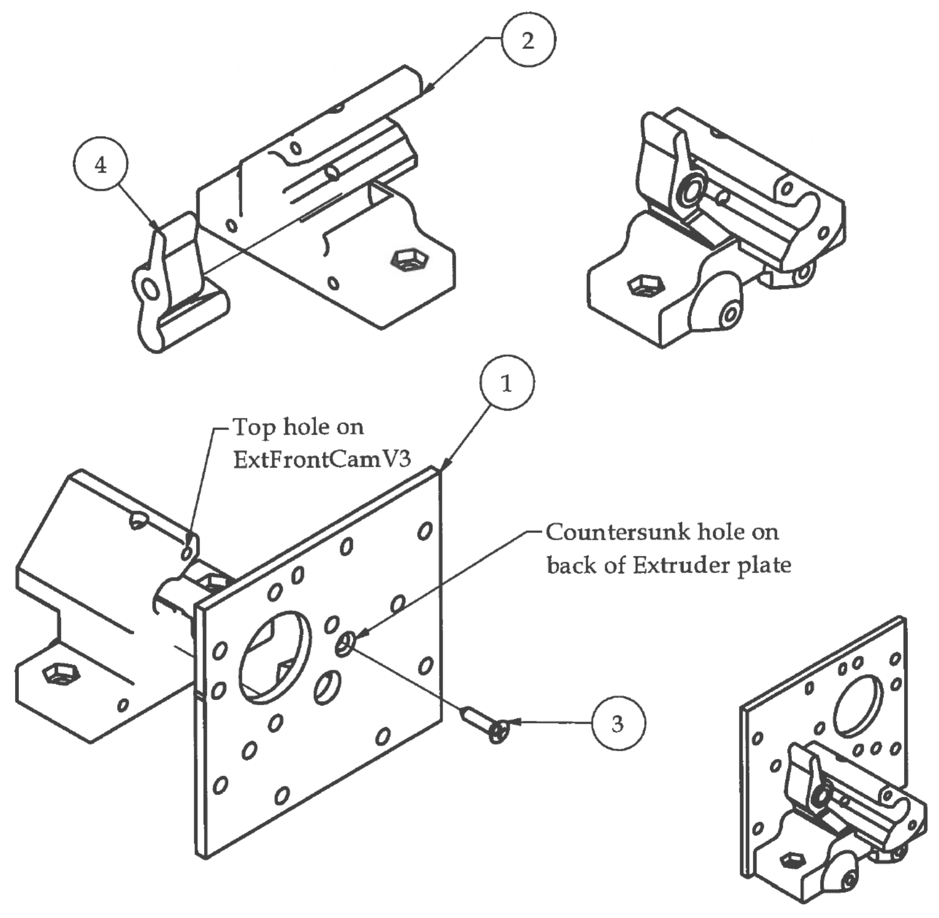Insert pinchLeverV2 into extFrontCamV3 as shown.
2. Attach extFrontCamV3 to extBackPlateV2 with single screw to hold in place.
3. Do not over tighten screw or you might strip out the plastic.
4. When step is completed it should look like the picture to the right. In Step 2, this step will be referred to as Step 1.

|  |  |  |  |
| --- | --- | --- | --- |
| **PARTS LIST** | | | |
| **ITEM** | **QTY** | **PART NUMBER** | **DESCRIPTION** |
| 1 | 1 | extruderBackPlateV2 | Custom aluminum part |
| 2 | 1 | extFrontCamV3 | 3D printed part |
| 3 | 1 | No.4 x 1/2 cs | Nuts and bolts |
| 4 | 1 | pinchLeverV2 | 3D printed part |
|  |  | Micro Philips Screwdriver | Tools |

Step 2

|  |  |  |  |
| --- | --- | --- | --- |
| **PARTS LIST** | | | |
| **ITEM** | **QTY** | **PART NUMBER** | **DESCRIPTION** |
| 1 | 1 | Step 1 | Previous assembly |
| 2 | 1 | NEMA 14 stepper moto | Electrical kit |
| 3 | 4 | M3 x 6 | Nuts and bolts |
|  |  | M2.5 Hex Wrench | Tools |

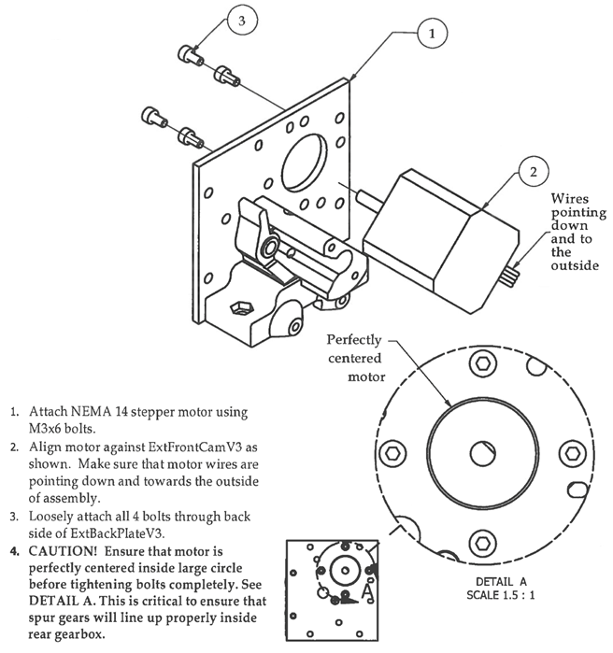

1. Attach NEMA 14 stepper motor using   
   M3 x 6 bolts.
2. Align motor against ExtFrontCamV3 as shown. Make sure that motor wires are pointing down and towards the outside of assembly.
3. Loosely attach all 4 bolts through back side of the ExtBackPlateV3.
4. **CAUTION! Ensure that motor is perfectly centered inside large circle before tightening bolts completely. See   
   DETAIL A. This is critical to ensure that spur gears will line up properly inside rear gearbox.**

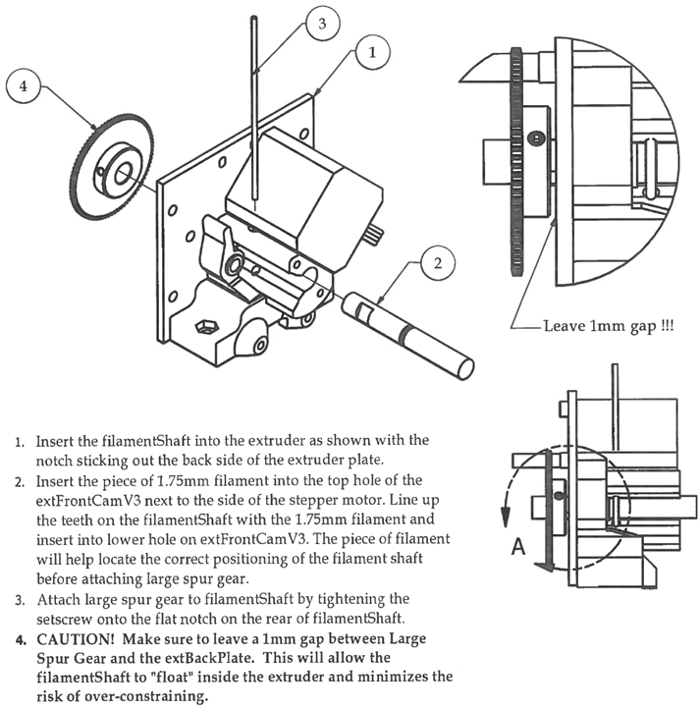Step 3

1. Insert the filamentShaft into the extruder as shown with the notch sticking out of the back side of the extruder plate.
2. Insert the piece of 1.75mm filament into the top hole of the extFrontCamV3 next to the side of the stepper motor.   
   Line up the teeth on the filamentShaft with the 1.75mm filament and insert into lower hole on extrontCamV3.   
   The piece of filament will help locate the correct positioning of the filament shaft before attaching large spur gear.
3. Attach large spur gear to filamentShaft by tightening the setscrew onto the flat notch on the rear of filamentShaft.
4. **CAUTION! Make sure to leave a 1mm gap between Large Spur Gear and the extBackPlate. This will allow the filamentShaft to “float” inside the extruder and minimize the risk of over-constraining.**

|  |  |  |  |
| --- | --- | --- | --- |
| **PARTS LIST** | | | |
| **ITEM** | **QTY** | **PART NUMBER** | **DESCRIPTION** |
| 1 | 1 | Step 2 | Previous sub-assembly |
| 2 | 1 | filamentShaft | CNC milled parts |
| 3 | 1 | 1.75mm Filament 100mm | Break off from 1.755 mm PLA filament reel |
| 4 | 1 | Large Spur Gear - 80 tooth | Off-the-shelf components |
|  |  | M1.5 Hex Wrench | Tools |

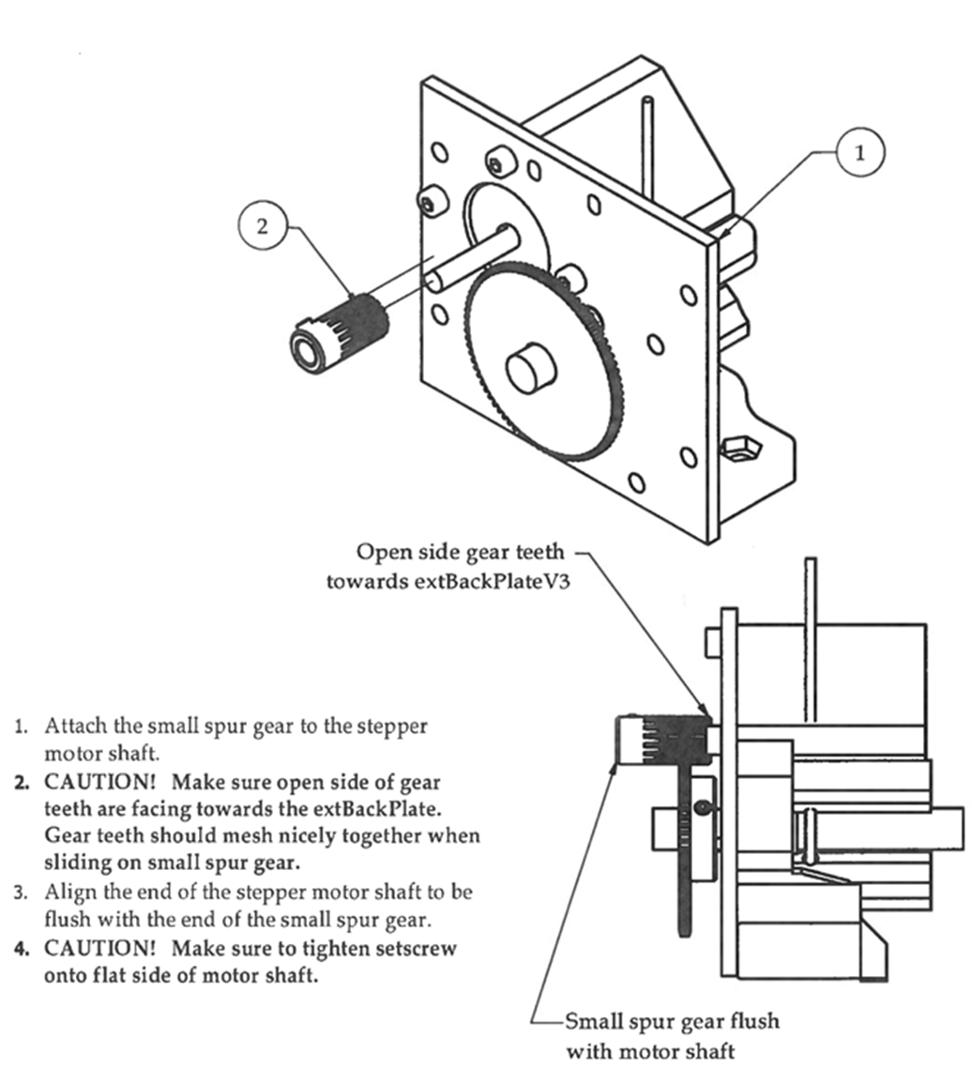Step 4

1. Attach the small spur gear to the stepper motor shaft.
2. **CAUTION! Make sure open side of gear teeth are facing towards the extBackPlate. Gear teeth should mesh nicely together when sliding on small spur gear.**
3. Align the end of the stepper motor shaft to be flush with the end of the small spur gear.
4. **CAUTION! Make sure to tighten setscrew onto flat side of motor shaft.**

|  |  |  |  |
| --- | --- | --- | --- |
| **PARTS LIST** | | | |
| **ITEM** | **QTY** | **PART NUMBER** | **DESCRIPTION** |
| 1 | 1 | Step 3 | Previous sub-assembly |
| 2 | 1 | Small Spur Gear - 16 tooth | Off-the-shelf components |
|  |  | M1.5 Hex Wrench | Tools |

Step 5

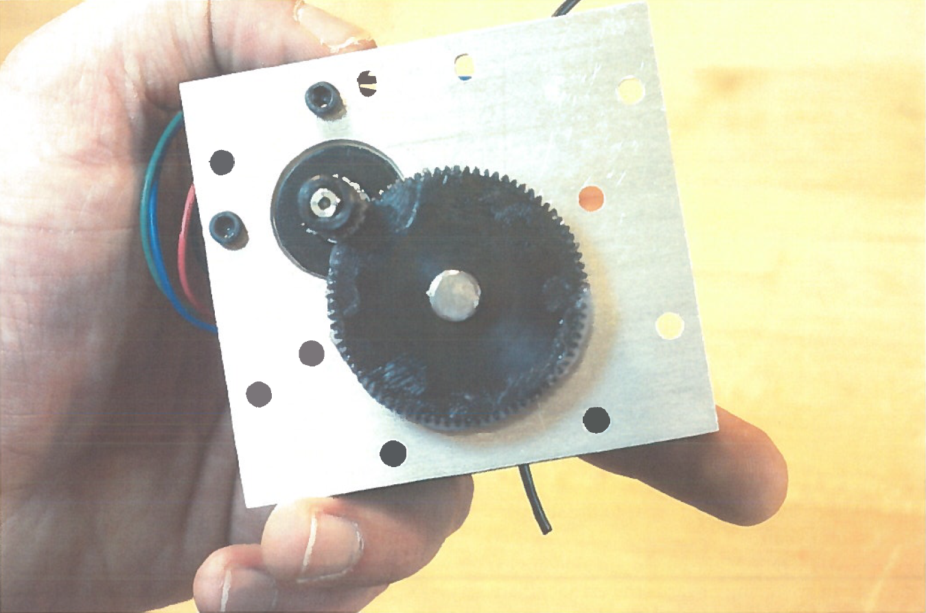

1. Apply ceramic grease—which can be purchased at a bike shop, evenly to all gear teeth on the large spur gear making sure to get in the grooves between the teeth.

2. Try not to over-apply the grease.

3. Rotate the small spur gear several times to spread the grease evenly between both spur gears.

Step 6

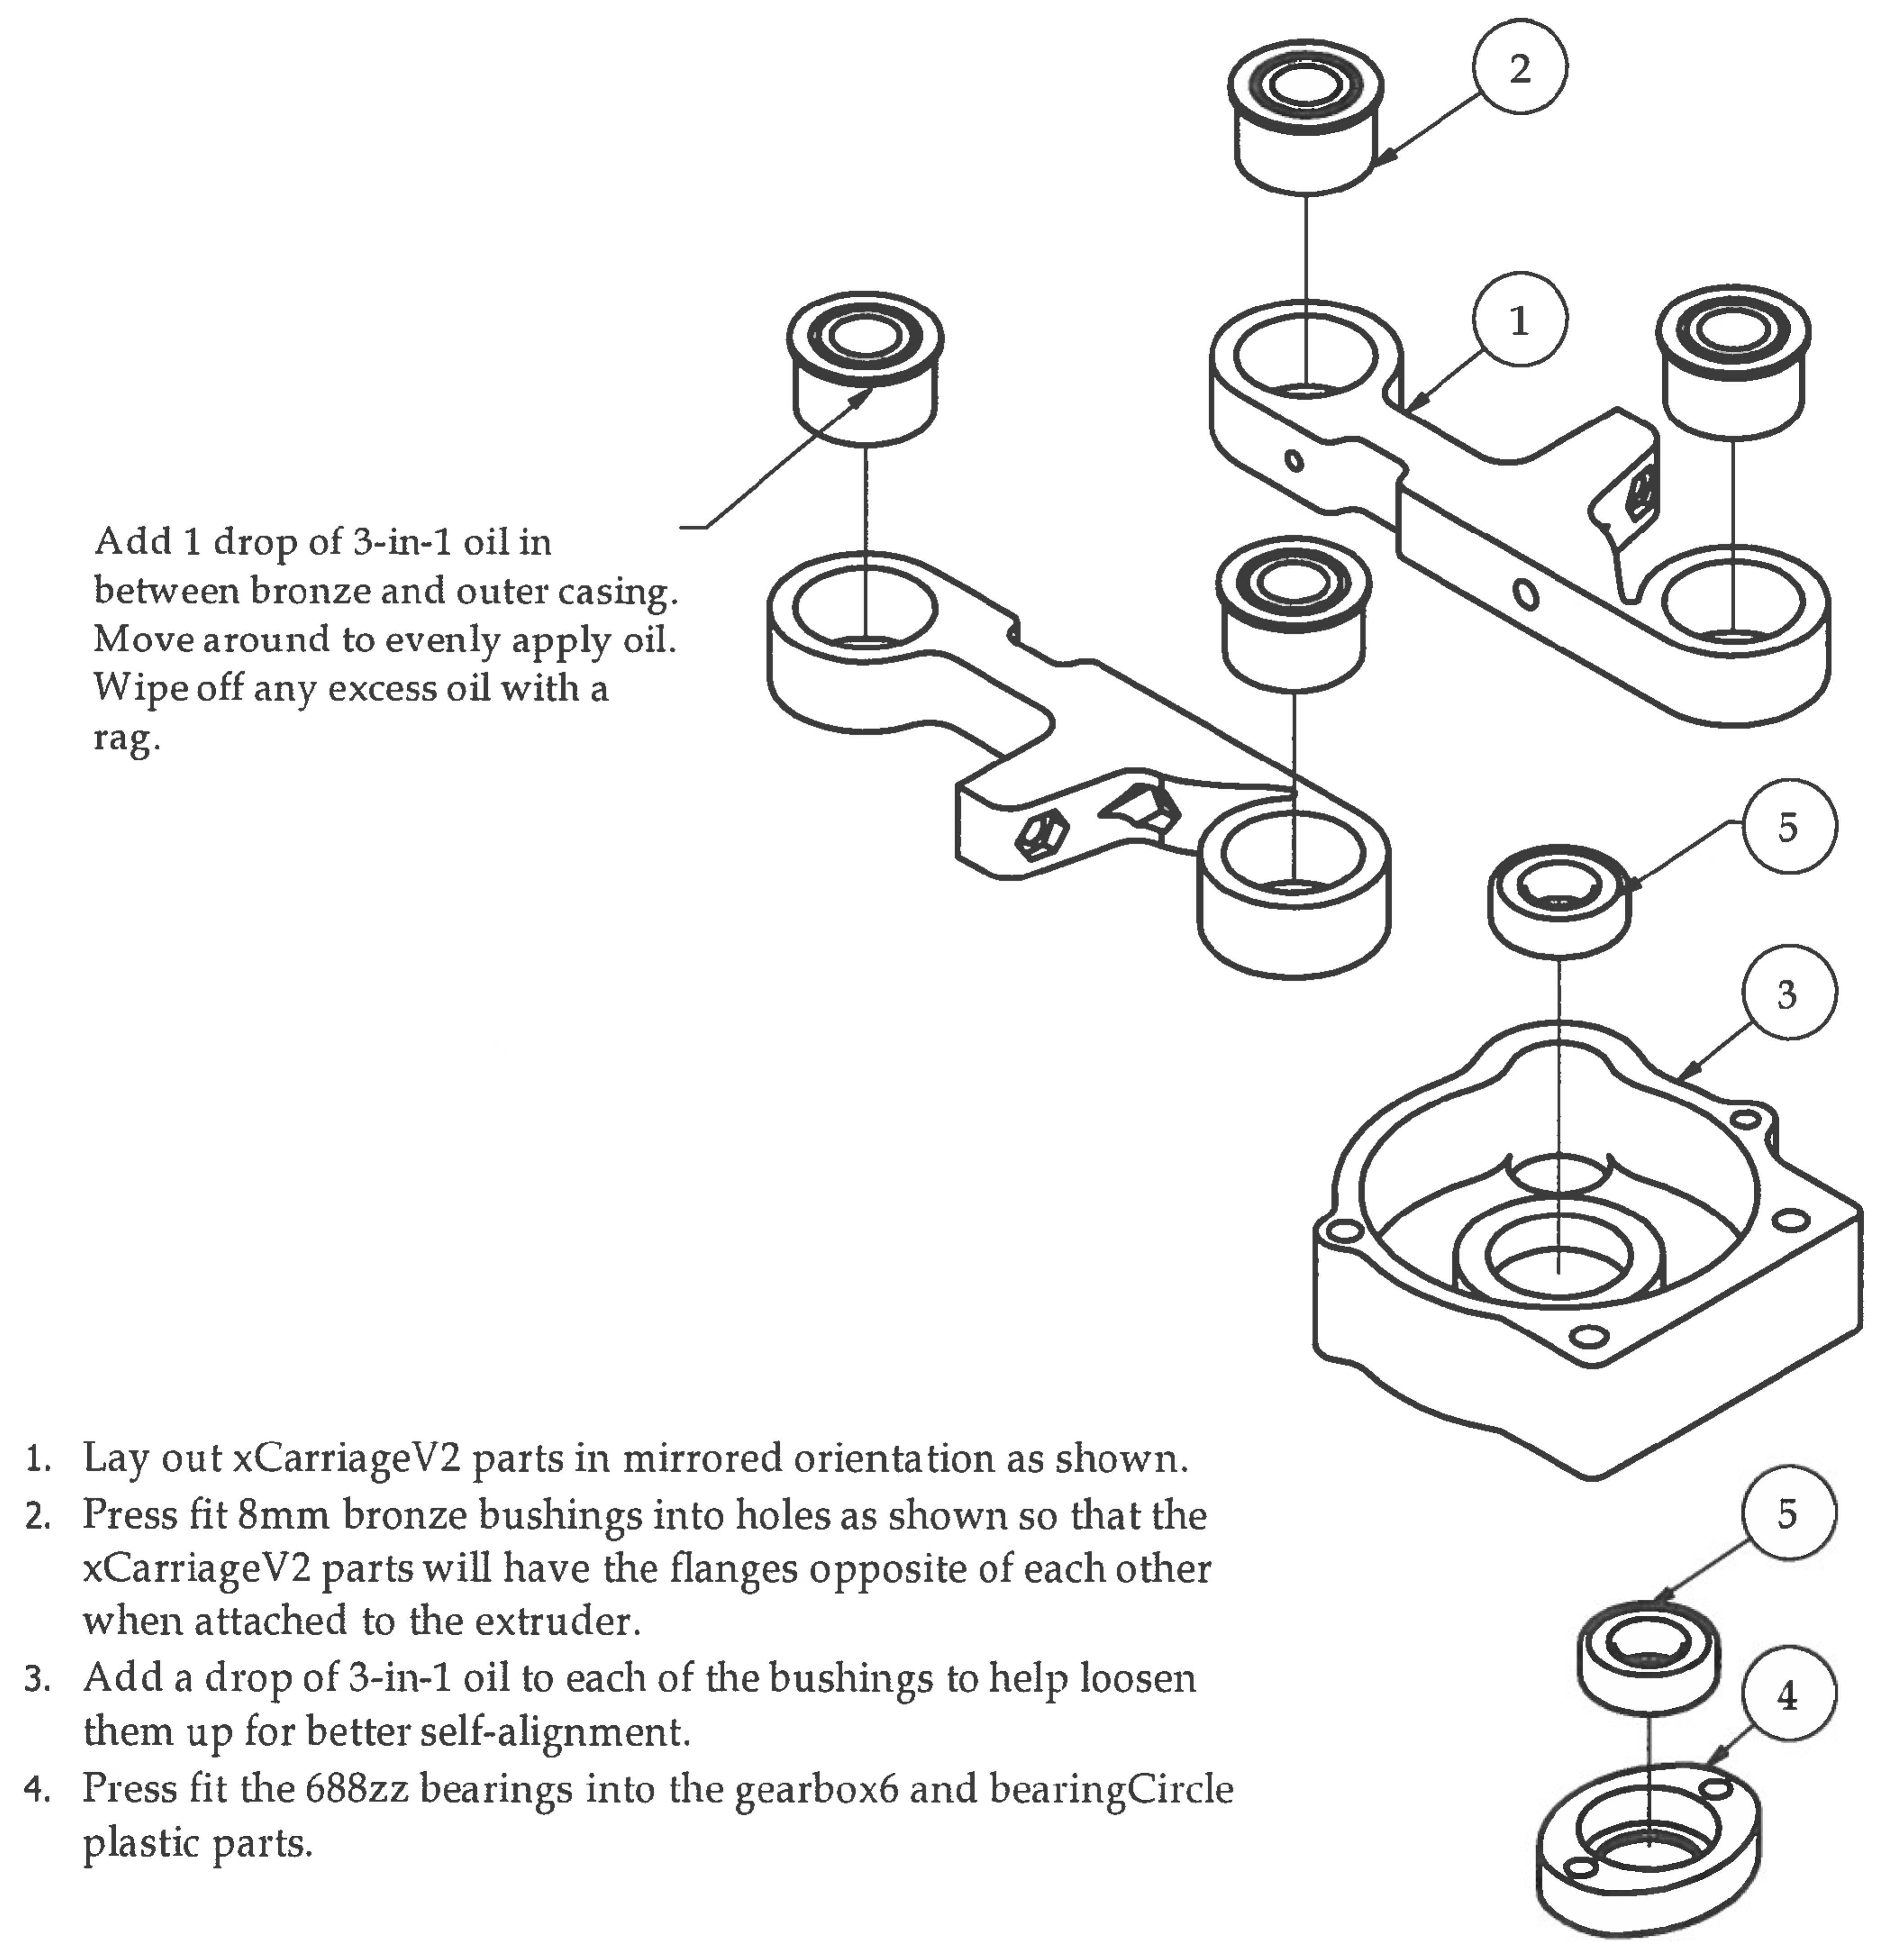

Add 1 drop of 3-in-1 oil in between bronze and outer casing. Move around to evenly apply oil. Wipe off any excess oil with a rag.

1. Lay out xCarriageV2 parts in mirrored orientation as shown.
2. Press fit 8mm bronze bushings into holes as shown so that the xCarriageV2 parts will have the flanges opposite of each other when attached to the extruder.
3. Add a drop of 3-in-1 oil to each of the bushings to help loosen them up for better self-alignment.
4. Press fit the 688zzbearings into the gearbox6 and bearingCircle plastic parts.

|  |  |  |  |
| --- | --- | --- | --- |
| **PARTS LIST** | | | |
| **ITEM** | **QTY** | **PART NUMBER** | **DESCRIPTION** |
| 1 | 2 | xCarrigeV2 | 3D printed part |
| 2 | 4 | 8mm Bronze Bushing | Off the shelf component |
| 3 | 1 | gearbox6 | 3D printed part |
| 4 | 1 | bearngCircle | 3D printed part |
| 5 | 2 | 688xx Bearing | Off the shelf component |

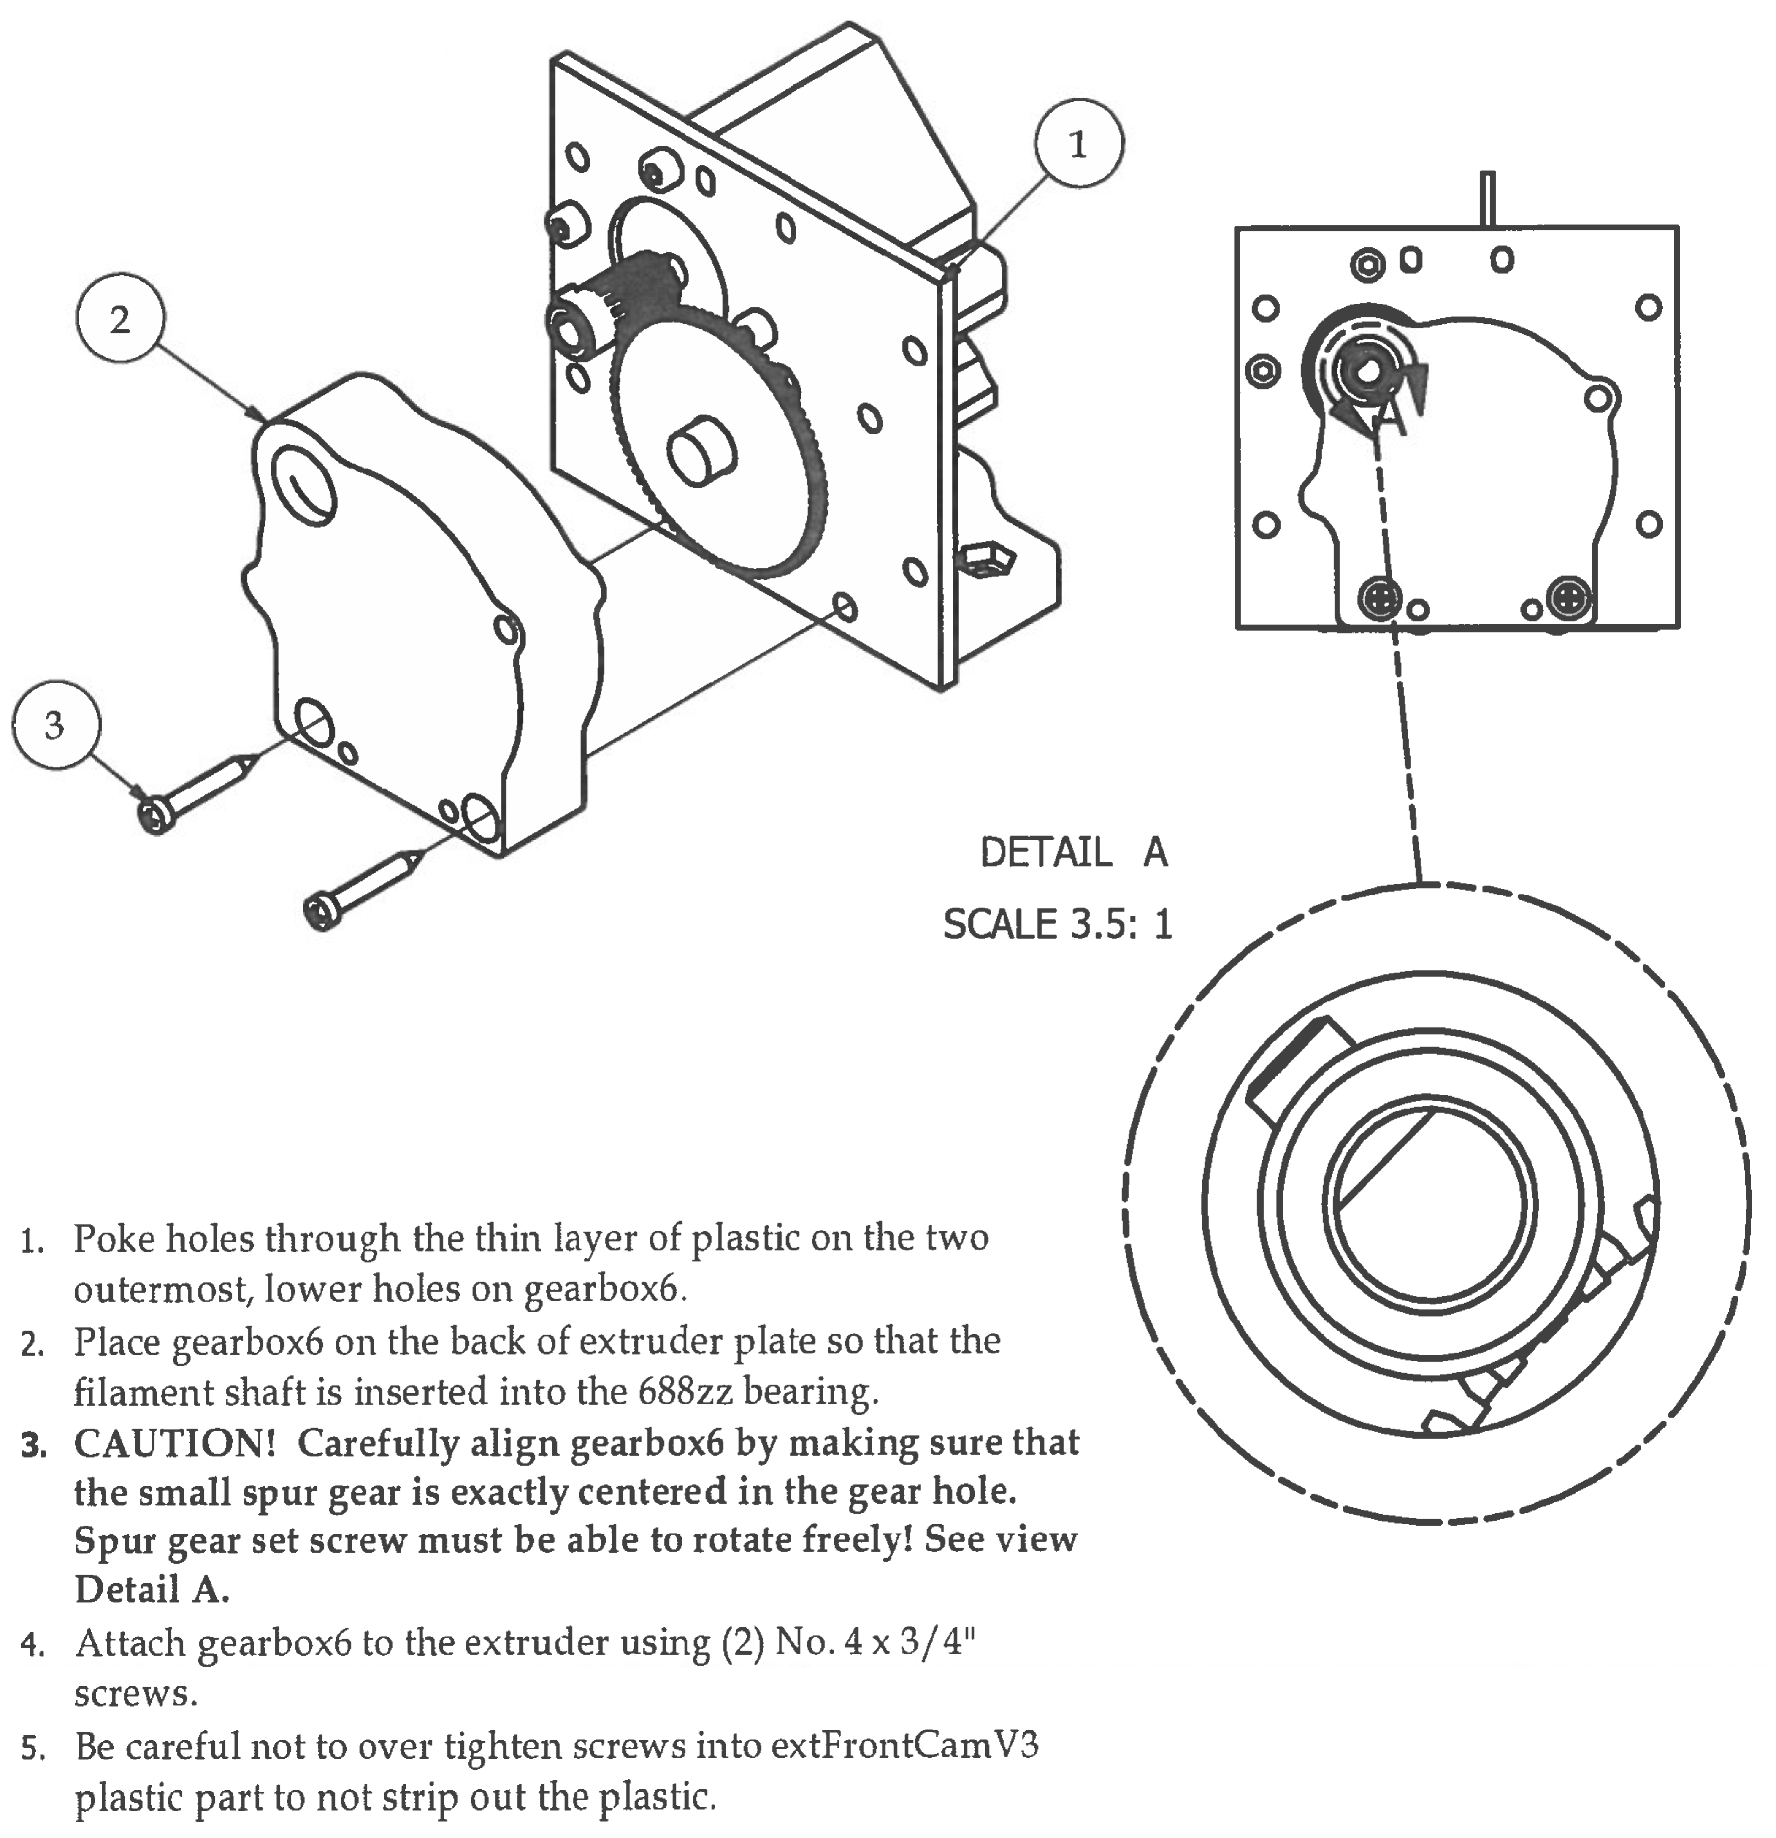Step 7

|  |  |  |  |
| --- | --- | --- | --- |
| **PARTS LIST** | | | |
| **ITEM** | **QTY** | **PART NUMBER** | **DESCRIPTION** |
| 1 | 1 | Step5 | Previous sub-assembly |
| 2 | 1 | Step6.2 | Previous sub-assembly |
| 3 | 2 | No.4 - 24 - 3/4" | Nuts and bolts |
|  |  | Micro Phillips Screwdriver | Tools |

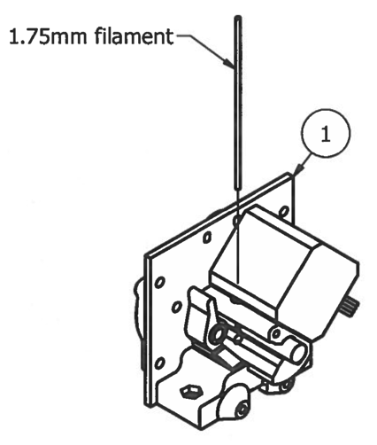Step 8

This is a CHECK POINT to detect any over­constraining! We will perform the "Jiggle Test" to make sure that the filamentShaft has the ability to float inside the extruder. We will be performing this test several more times throughout the assembly of the extruder and will reference it as a "Jiggle Test".

1. Slowly remove the strand of l.75mm filament from the extruder.

2. Holding the extruder with two hands, shake the extruder back and forth and listen for the extruderShaft to click as it moves back and forth inside the extruder.

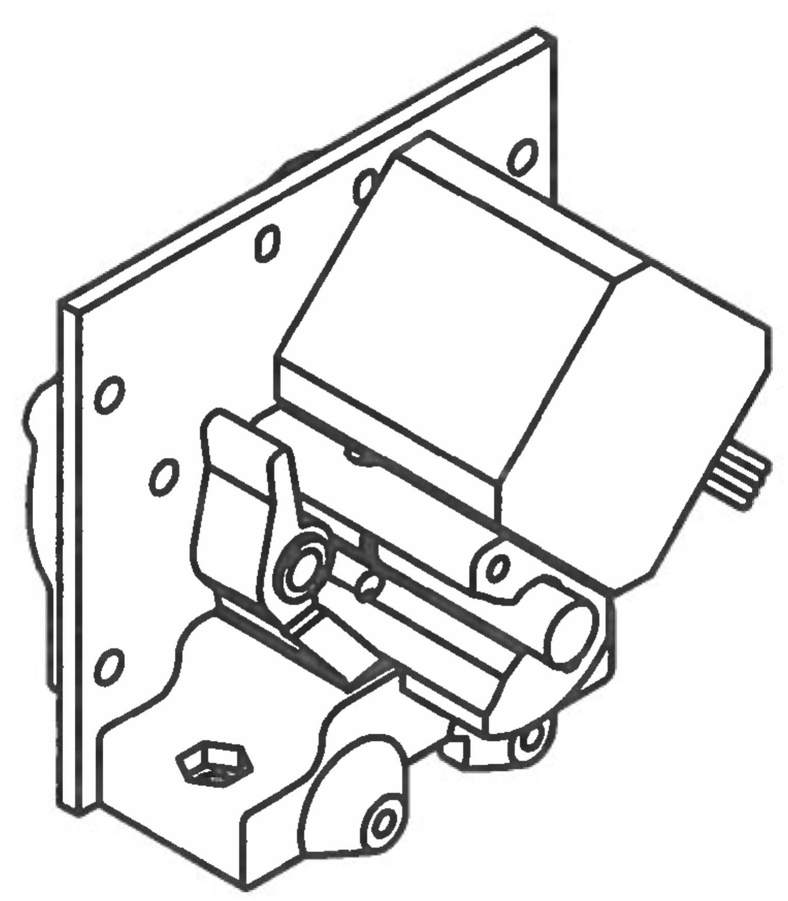3. If you hear the clicking sound, then your extruderShaft is free to float back and forth and you can continue to the next assembly step.

4. If you DO NOT hear the filament shaft clicking back and forth as it is being shaken, then your filament shaft is over-constrained and is unable to float freely inside the extruder.

5. To fix this, unscrew the last two screws installed in the back of gearbox6, realign the gear hole in gearbox6 with the small spur gear and tighten screws again.

6. Repeat "Jiggle Test". If you hear the filament shaft clicking, you have resolved the issue and can move on to the next step.

7. If not, repeat steps 5 and 6 on this page until passing the Jiggle Test.